

**Vincent Mary School of Engineering**

**EE3704 Embedded System**

**Name:** Todsavad Tangtortan

**ID:** 6114215

**Submission Date:**31/05/2021

**Work Contribution**

|  |  |
| --- | --- |
| 1. Todsavad Tangtortan | 100% |

**INTRODUCTION**

An embedded system combines mechanical, electrical, and chemical components along with a computer, hidden inside, to perform a single dedicated purpose. There are more computers on this planet than there are people, and most of these computers are single-chip microcontrollers that are the brains of an embedded system. Embedded systems are a ubiquitous component of our everyday lives.

We interact with hundreds of tiny computers every day that are embedded into our houses, our cars, our bridges, our toys, and our work. As our world has become more complex, so have the capabilities of the microcontrollers embedded into our devices. Therefore, the world needs a trained workforce to develop and manage products based on embedded microcontrollers

Following is the list of all Chapter from EE3704,

CHAPTER 1 : INTRODUCTION TO ARDUINO BOARD

CHAPTER 2: DIGITAL OUTPUT

CHAPTER 3: DIGITAL OUTPUT

CHAPTER 4: SERIAL COMMUNICATION

CHAPTER 5: ANALOG INPUT

CHAPTER 6: PULSE WIDTH MODULATION (PWM)

CHAPTER 6.5: PCB DESIGN

CHAPTER 7: Timer and External Interrupt

**CHAPTER 1 : INTRODUCTION TO ARDUINO BOARD**

**Example 1.1**

* Try Basic Command to Arduino Board
* Turn On/Off onboard LED (Pin 13) for 1 second
* delay function is delay(ms);

**Diagram:**

Pin 13 is the onboard LED itself which exists on the Arduino board.

**Coding:**

void setup() {

pinMode(13, OUTPUT);

}

void setup() {

digitalWrite(13, HIGH);

delay(2000);

digitalWrite(13, LOW);

delay(1000);

}

**Result:**

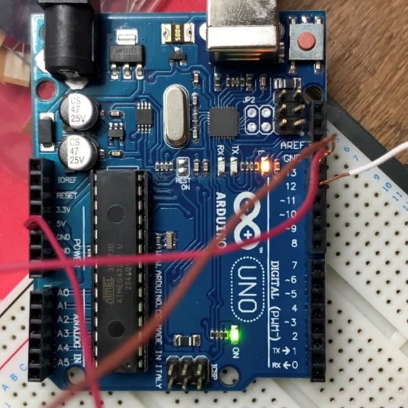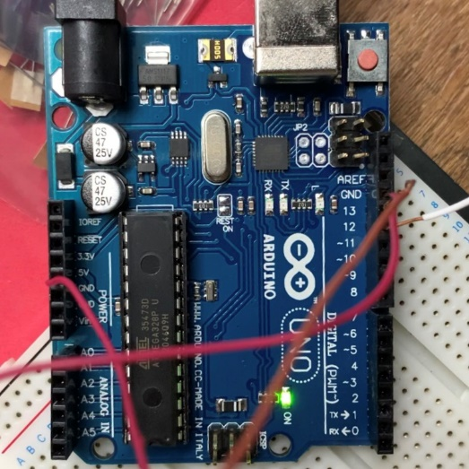

**Figure 1.1.1: LED OFF Figure 1.1.2: LED ON**

**Example 1.2**

* Turn On onboard LED (Pin 13 ) for 2 second
* Then Turn Off onboard LED ( Pin 13) for 1 second
* Do it 5 time ( On and Off )
* The onboard LED (Pin 13) turn Off

**Diagram:**

Pin 13 is the onboard LED itself which exists on the Arduino board.

**Coding:**

void setup() {

pinMode(13, OUTPUT);

for(char a=0;a<5;a=a+1){

digitalWrite(13, HIGH);

delay(2000);

digitalWrite(13, LOW);

delay(1000);

}

}

**Result:**



**Figure 1.2.1: LED OFF Figure 1.2.2: LED ON**

**Example 1.3**

* Turn On LED (Pin 12 ) for 2 second
* Then Turn Off LED ( Pin 12) for 1 second
* Do it 5 time ( On and Off

**Diagram:**

Pin 12 is the onboard LED itself which exists on the Arduino board.

**Coding:**

void setup(){

pinMode(12, OUTPUT);

int a;

for(a=0;a<5;a=a+1){

digitalWrite(12, HIGH);

delay(2000);

digitalWrite(12, LOW);

delay(1000);

}

}

**Result:**



**Figure 1.3.1: LED OFF Figure 1.3.2: LED ON**

**Conclusion:**

In chapter 1, a basic concept, coding, and usage of Arduino were introduced. pinMode is a function used to declare the pin duty either as output or input. Where digitalWrite is a function used to command status of a particular pin to be either HIGH or LOW depends on the circuit mechanism. Moreover, some fundamental of C language were being reviewed and adapted into the coding process.

**CHAPTER 2: DIGITAL OUTPUT**

**Example 2.1: Active High load**

* Turn On / Off LED (Pin 13) for 5 times
* Check the LED output
  + Tinkercad
  + Real Arduino board

**Diagram:**

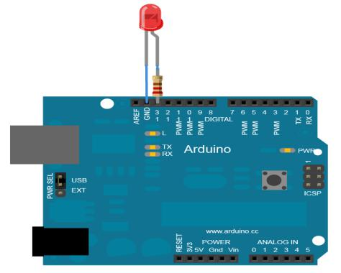

**Coding:**

void setup(){

pinMode(12, OUTPUT);

int a;

for(a=0;a<5;a=a+1){

digitalWrite(12, HIGH);

delay(2000);

digitalWrite(12, LOW);

delay(1000);

}

}

**Result:**



**Figure 2.1.1: LED OFF Figure 2.1.2: LED ON**

**Example 2.2: Active High and Active Low loads**

* Turn On / Off LED (Pin 13 and Pin 12) for 5 times
* Check the LED output
  + Tinkercad
  + Real Arduino board

**Diagram:**

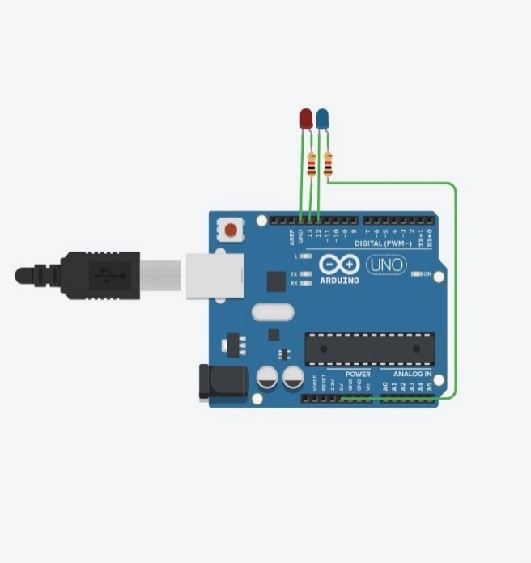

**Coding:**

void setup(){

pinMode(13, OUTPUT);

pinMode(12, OUTPUT);

int a;

for(a=0;a<5;a=a+1)

{

digitalWrite(13, HIGH);

digitalWrite(12, LOW);

delay(2000);

digitalWrite(13, LOW);

digitalWrite(12, HIGH);

delay(1000);

}

**Result:**

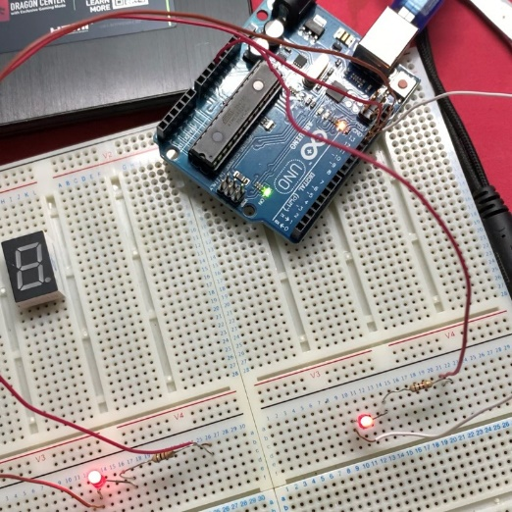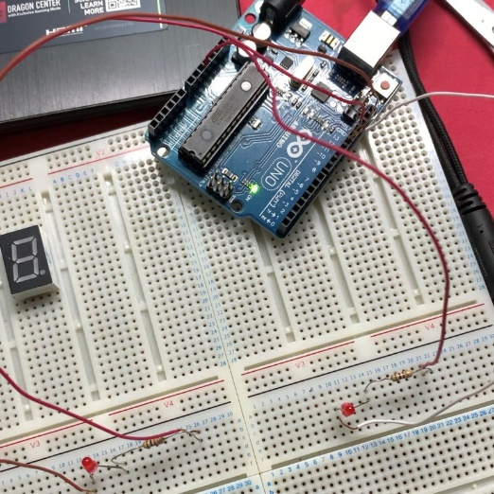

**Figure 2.2.1: LED OFF Figure 2.2.2: LED ON**

**Example 2.3 (all Active Low)**

* Connect LED to Pin 0 to 3
* Turn On / Off LED Pin 0 to 3 with delay of 1 second
* Use function delay(ms);
* Show Circuit diagram / and Coding
  + Tinkercad
  + Real Arduino board

**Diagram:**

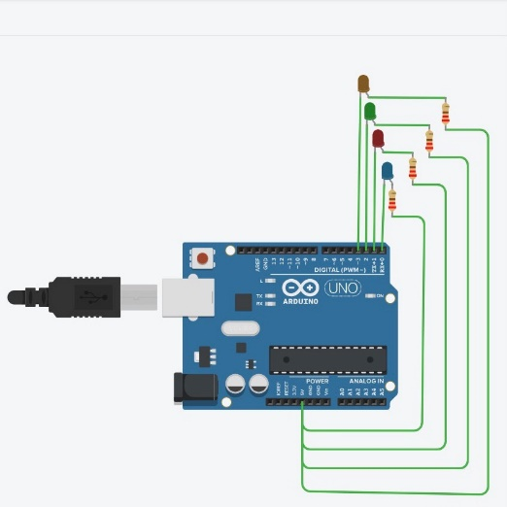

**Coding:**

void setup(){

pinMode(0, OUTPUT);

pinMode(1, OUTPUT);

pinMode(2, OUTPUT);

pinMode(3, OUTPUT);

int a;

for(a=0;a<5;a=a+1){

digitalWrite(0, LOW);

digitalWrite(1, HIGH);

digitalWrite(2, HIGH);

digitalWrite(3, HIGH);

delay(1000);

digitalWrite(0, HIGH);

digitalWrite(1, LOW);

digitalWrite(2, HIGH);

digitalWrite(3, HIGH);

delay(1000);

digitalWrite(0, HIGH);

digitalWrite(1, HIGH);

digitalWrite(2, LOW);

digitalWrite(3, HIGH);

delay(1000);

digitalWrite(0, HIGH);

digitalWrite(1, HIGH);

digitalWrite(2, HIGH);

digitalWrite(3, LOW);

delay(1000);

digitalWrite(0, HIGH);

digitalWrite(1, HIGH);

digitalWrite(2, HIGH);

digitalWrite(3, HIGH);

}

}

**Result:**

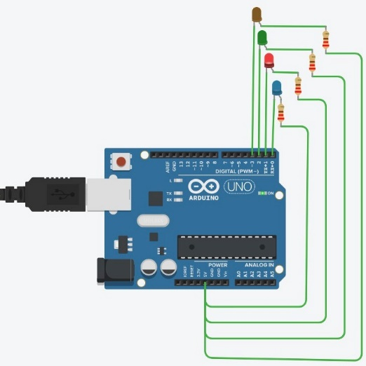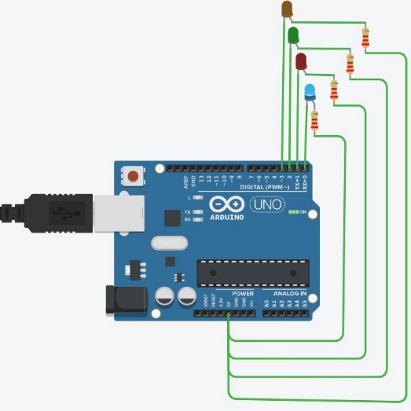

**Figure 2.3.1: LED 1 ON Figure 2.3.2: LED 2 ON**

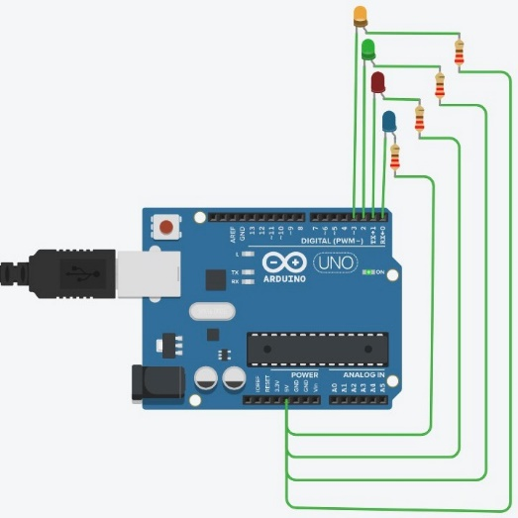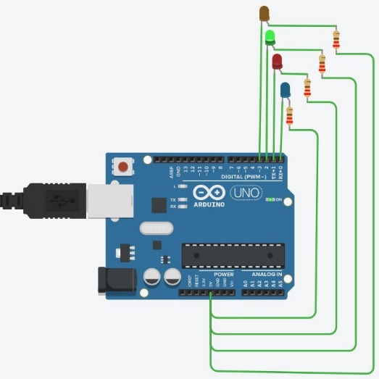

**Figure 2.3.3: LED 3 ON Figure 2.3.4: LED 4 ON**

**Example 2.4: 7 Segment (CC or CA)**

* Make 7 segment display number 5
* Pins starting from Pin2 to Pin 8
* Check the 7 segment display
  + Tinkercad
  + Real Arduino board

**Diagram:**

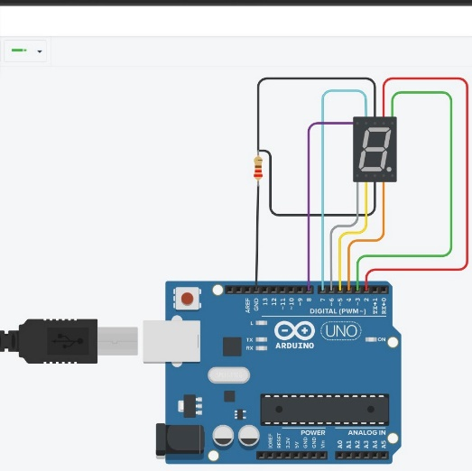

**Coding:**

void setup(){

pinMode(2, OUTPUT);

pinMode(3, OUTPUT);

pinMode(4, OUTPUT);

pinMode(5, OUTPUT);

pinMode(6, OUTPUT);

pinMode(7, OUTPUT);

pinMode(8, OUTPUT);

}

void loop(){

digitalWrite(2, HIGH);

digitalWrite(7, HIGH);

digitalWrite(8, HIGH);

digitalWrite(4, HIGH);

digitalWrite(5, HIGH);

delay(1000); // Wait for 1000 millisecond(s)

digitalWrite(2, LOW);

digitalWrite(7, LOW);

digitalWrite(8, LOW);

digitalWrite(4, LOW);

digitalWrite(5, LOW);

delay(1000); // Wait for 1000 millisecond(s)

}

**Result:**

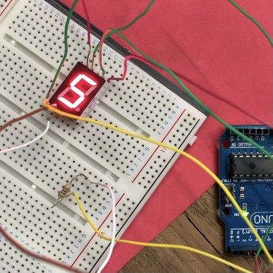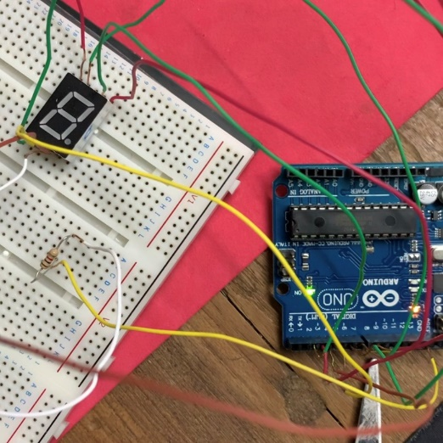

**Figure 2.4.1: LED OFF Figure 2.4.2: LED ON**

**Example 2.5: 7 Segment (CC or CA)**

* Make 7 segment display number 5 using array
* Pins starting from Pin2 to Pin 8

**Diagram:**



**Coding:**

void setup() {

for (char i = 2; i<9; i++ )

{

pinMode(i, OUTPUT);

}

}

void loop() {

//Use CC 7 segment

int number_5[7] = {1,0,1,1,0,1,1}; // a,b,c,d,e,f,g

for (char pin=2; pin<9; pin++){

digitalWrite(pin, number_5[pin-2]);

}

}

**Result:**



**Figure 2.5.1: LED OFF Figure 2.5.2: LED ON**

**Example 2.6: 7 Segment (CC or CA)**

* Make 7 segment display number 4 and 5 with 1s interval using array
* Pins starting from Pin2 to Pin 8
* Check the 7 segment display
  + Tinkercad
  + Real Arduino board

**Diagram:**



**Coding:**

void setup() {

for (char i = 2; i<9; i++ )

{

pinMode(i, OUTPUT);

}

}

void loop() {

//Use CC 7 segment

int number_45[2][7] = {{0,1,1,0,0,1,1}, //row0

{1,0,1,1,0,1,1}}; // a,b,c,d,e,f,g

for (char row=0; row<2; row++) {

for (char pin=2; pin<9; pin++) {

digitalWrite(pin, number_45[row][pin-2]);

}

delay(1000);

}

}

**Result:**

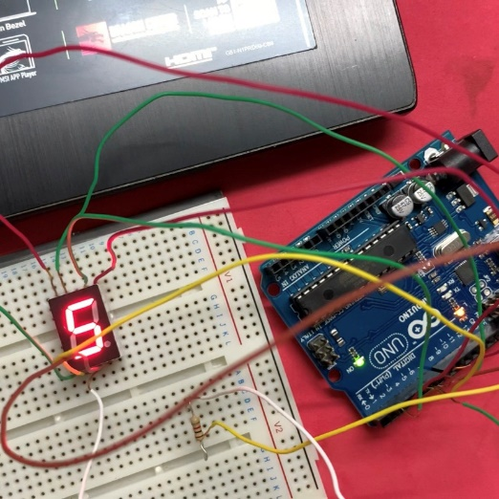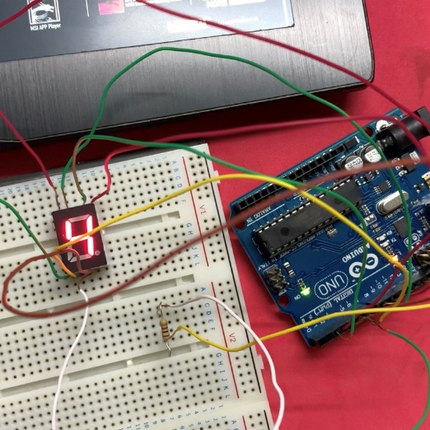

**Figure 2.6.1: LED 4 Figure 2.6.2: LED 5**

**Example 2.7: 7 Segment (CC or CA)**

* 7 Segment running 0 – 9 and repeat with delay of 1 second
* Show Circuit diagram / and Coding
  + Tinkercad
  + Real Arduino board

**Diagram:**



**Coding:**

void setup() {

for (char i = 2; i<9; i++ ){

pinMode(i, OUTPUT);

}

}

void loop() {

//Use CC 7 segment

int number_09[10][7] ={ {1,1,1,1,1,1,0}, //row0

{0,1,1,0,0,0,0}, //row1

{1,1,0,1,1,0,1}, //row2

{1,1,1,1,0,0,1}, //row3

{0,1,1,0,0,1,1}, //row4

{1,0,1,1,0,1,1}, //row5

{1,0,1,1,1,1,1}, //row6

{1,1,1,0,0,0,0}, //row7

{1,1,1,1,1,1,1}, //row8

{1,1,1,1,0,1,1},};//row9 //a,b,c,d,e,f,g

for (char row=0; row<10; row++) {

for (char pin=2; pin<9; pin++) {

digitalWrite(pin, number_09[row][pin-2]);

}

delay(1000);

}

}

**Result:**

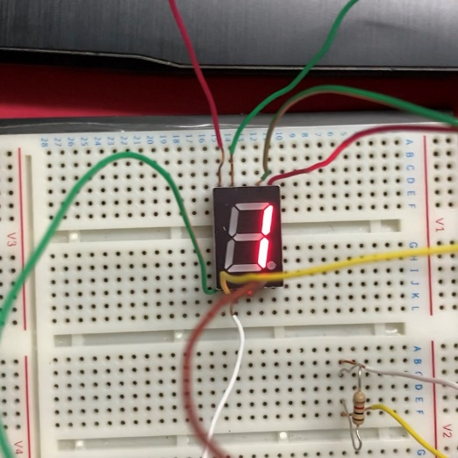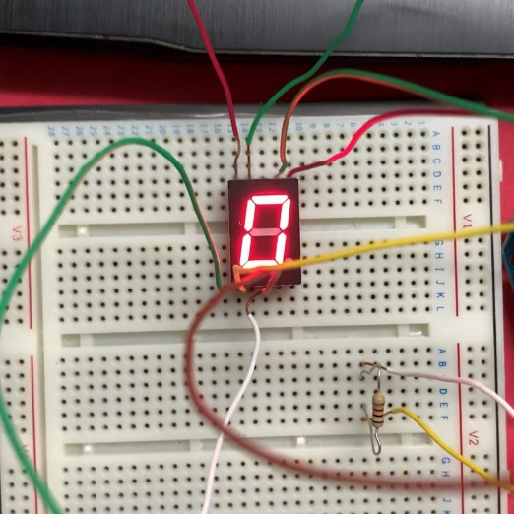

**Figure 2.7.1: LED ‘0’ Figure 2.7.2: LED ‘1’**

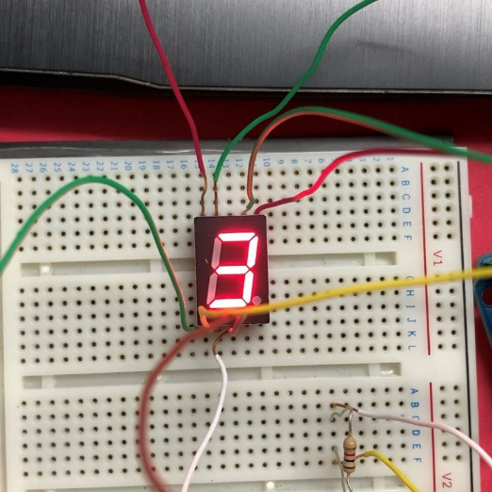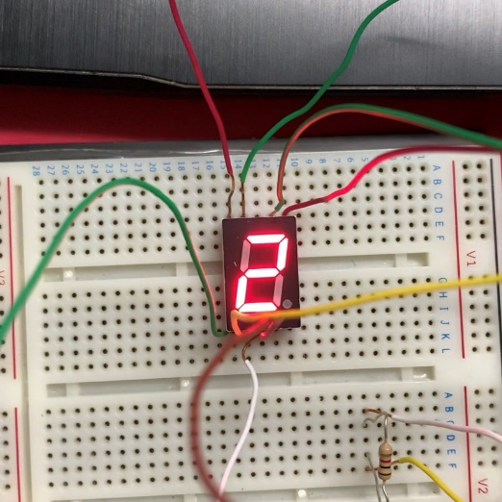

**Figure 2.7.3: LED ‘2’ Figure 2.7.4: LED ‘3’**

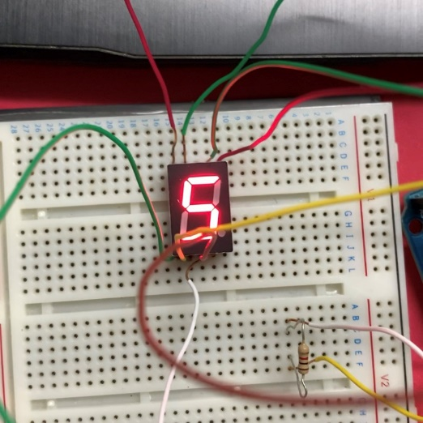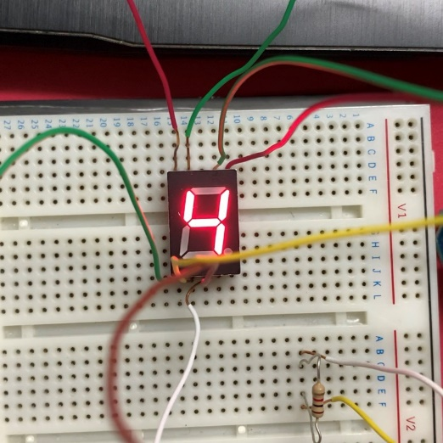

**Figure 2.7.5: LED ‘4’ Figure 2.7.6: LED ‘5’**

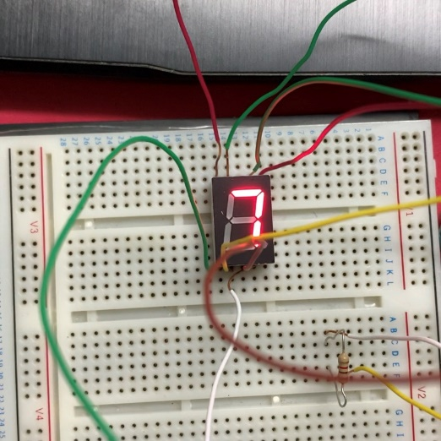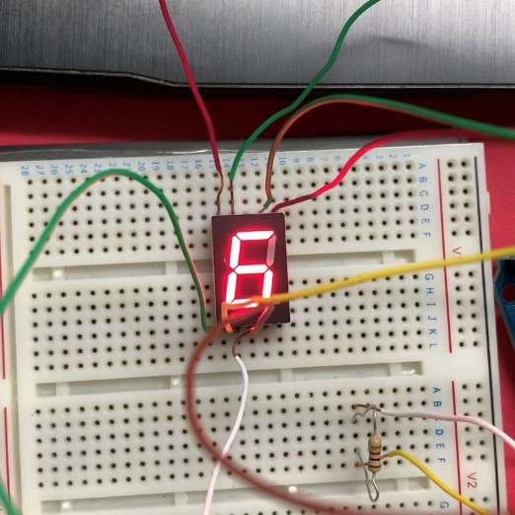

**Figure 2.7.7: LED ‘6’ Figure 2.7.8: LED ‘7’**

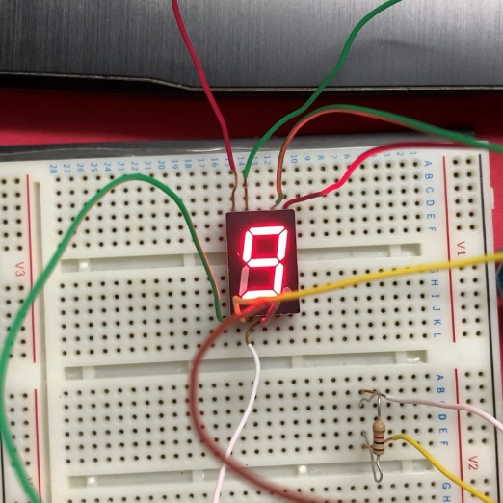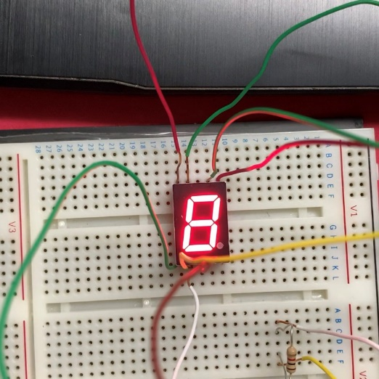

**Figure 2.7.9: LED ‘8’ Figure 2.7.10: LED ‘9’**

**Example 2.8 : 7 Segment (CC or CA)**

* Make Led on 7 segment start at ‘a’ and follow by ‘b’, and so on……… until ‘g’ with 1 s delay.
* When it reached ‘g’ and go reveres as follow ‘f’ so on……… until back to ‘a’ with 1 s delay.
* Then repeat the process • Show Circuit diagram / and Coding
  + Tinkercad
  + Real Arduino board

**Diagram:**



**Coding:**

void setup() {

for (char i = 2; i<9; i++ ){

pinMode(i, OUTPUT);

}

}

void loop() {

//Use CC 7 segment

int number_09[7][7] ={ {1,0,0,0,0,0,0}, //row0a

{1,1,0,0,0,0,0}, //row1b

{1,1,1,0,0,0,0}, //row2c

{1,1,1,1,0,0,0}, //row3d

{1,1,1,1,1,0,0}, //row4e

{1,1,1,1,1,1,0}, //row5f

{1,1,1,1,1,1,1}, //row6g}; //a,b,c,d,e,f,g

for (char row=0; row<7; row++) {

for (char pin=2; pin<9; pin++) {

digitalWrite(pin, number_09[row][pin-2]);

}

delay(1000);

}

for (char row=6; row>=0; row--) {

for (char pin=2; pin<9; pin++) {

digitalWrite(pin, number_09[row][pin-2]);

}

delay(1000);

}

}

**Result:**



**Figure 2.8.1: LED ‘a’ Figure 2.8.2: LED ‘b’**



**Figure 2.8.3: LED ‘c’ Figure 2.8.4: LED ‘d’**



**Figure 2.8.5: LED ‘e’ Figure 2.8.6: LED ‘f’**



**Figure 2.8.7: LED ‘g’ Figure 2.8.8: LED ‘h’**

**Example 2.9: Use DDRx, PORTx registers**

* 7 Segment running 0 – 9 and repeat with delay of 1 second
* Pins starting from Pin2 to Pin 8 • Show Circuit diagram / and Coding
  + Tinkercad
  + Real Arduino board

**Diagram:**



**Coding:**

void setup() {

DDRD = 0xFC; //declare of Pin2-Pin7 of PortD

DDRB = 0x01; //declare of Pin8 of PortB

}

void loop() {

//Use CC 7 segment

//0

PORTD = (0x3F)<<2; //shift by 2 as it is on PD2

PORTB = (0x0);

delay(1000);

//1

PORTD = (0x06)<<2; //shift by 2 as it is on PD2

PORTB = (0x0);

delay(1000);

//2

PORTD = (0x1B)<<2; //shift by 2 as it is on PD2

PORTB = (0x1);

delay(1000);

//3

PORTD = (0x0F)<<2; //shift by 2 as it is on PD2

PORTB = (0x1);

delay(1000);

//4

PORTD = (0x26)<<2; //shift by 2 as it is on PD2

PORTB = (0x01);

delay(1000);

//5

PORTD = (0x2D)<<2; //shift by 2 as it is on PD2

PORTB = (0x01);

delay(1000);

//6

PORTD = (0x3D)<<2; //shift by 2 as it is on PD2

PORTB = (0x01);

delay(1000);

//7

PORTD = (0x07)<<2; //shift by 2 as it is on PD2

PORTB = (0x0);

delay(1000);

//8

PORTD = (0x3F)<<2; //shift by 2 as it is on PD2

PORTB = (0x01);

delay(1000);

//9

PORTD = (0x2F)<<2; //shift by 2 as it is on PD2

PORTB = (0x01);

delay(1000);

}

**Result:**

Similarly to Figure 2.7.1-2.7.10

**Example 2.10: Any method (DDRx or pinMode, Portx or digitalWrite)**

* CA 7 Segment running 0 – 9 and repeat with delay of 1 second
* Pins starting from Pin2 to Pin 8
* Show Circuit diagram / and Coding
  + Real Arduino board

**Diagram:**



**Coding:**

void setup() {

DDRD = 0xFC; //declare of Pin2-Pin7 of PortD

DDRB = 0x01; //declare of Pin8 of PortB

}

void loop() {

//Use CC 7 segment

//0

PORTD = (0x40)<<2; //shift by 2 as it is on PD2

PORTB = (0x1);

delay(1000);

//1

PORTD = (0x79)<<2; //shift by 2 as it is on PD2

PORTB = (0x1);

delay(1000);

//2

PORTD = (0x24)<<2; //shift by 2 as it is on PD2

PORTB = (0x0);

delay(1000);

//3

PORTD = (0x30)<<2; //shift by 2 as it is on PD2

PORTB = (0x0);

delay(1000);

//4

PORTD = (0x19)<<2; //shift by 2 as it is on PD2

PORTB = (0x0);

delay(1000);

//5

PORTD = (0x12)<<2; //shift by 2 as it is on PD2

PORTB = (0x0);

delay(1000);

//6

PORTD = (0x02)<<2; //shift by 2 as it is on PD2

PORTB = (0x0);

delay(1000);

//7

PORTD = (0x78)<<2; //shift by 2 as it is on PD2

PORTB = (0x1);

delay(1000);

//8

PORTD = (0x00)<<2; //shift by 2 as it is on PD2

PORTB = (0x0);

delay(1000);

//9

PORTD = (0x10)<<2; //shift by 2 as it is on PD2

PORTB = (0x0);

delay(1000);

}

**Result:**

Similarly to Figure 2.7.1-2.7.10

**Conclusion:**

In chapter two, a digital output of Arduino was introduced. It is simply to connect Arduino with external digital output devices such as LEDs and 7- segments. There are two kind of LED connections: Active High (AH) and Active Low (AL). AH connects from a digital output pin to the ground so it can operate when the output is high, where AL connects from 5V pin to a digital output pin so it can operate oppositely with AH (Low). The same concept goes to 7- segments as well with a different name: Common Cathode (AH) and Common Anode (AL). Furthermore, an alternative coding with DDRx and PORTx were introduced along this chapter so as to allow further communication with other devices in a future use.

**CHAPTER 3: DIGITAL OUTPUT**

**Example 3.1: Active high connection switch**

* When Switch is Pressed at Input (Pin 2)
  + Active high LED (Pin 13) turn On
* When Switch is not Pressed at Input (Pin 2)
  + Active high LED (Pin 13) turn Off

**Diagram:**

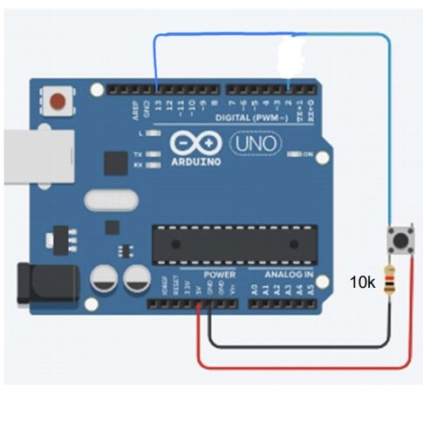

**Coding:**

void setup() {

pinMode(2,INPUT);

pinMode(13,OUTPUT);

}

void loop() {

bool SW = digitalRead(2); //Boolean

if(SW == 1) {

digitalWrite(13,HIGH); //LED ON

}

else {

digitalWrite(13,LOW); //LED OFF

}

}

**Result:**

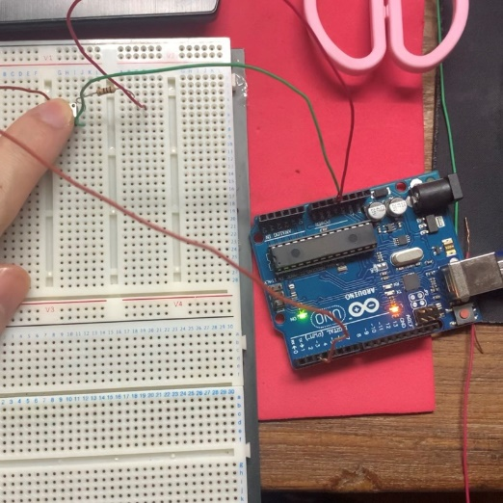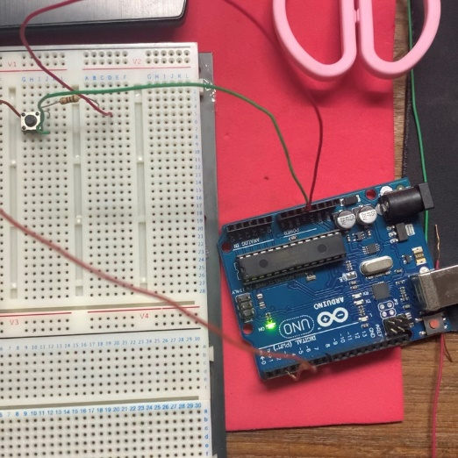

**Figure 3.1.1: LED OFF Figure 3.1.2: LED ON**

**Example 3.2: Active low connection switch**

* When Switch is Pressed at Input (Pin 3)
  + Active high LED (Pin 13) turn On
* When Switch is not Pressed at Input (Pin 3)
  + Active high LED (Pin 13) turn Off

**Diagram:**

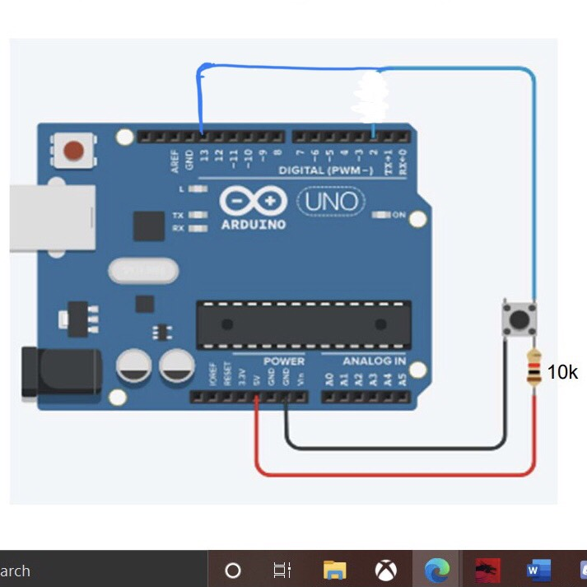

**Coding:**

void setup() {

pinMode(2,INPUT);

pinMode(13,OUTPUT);

}

void loop() {

bool SW = digitalRead(2); //Boolean

if(SW == 0){

digitalWrite(13,HIGH); //LED OFF

}

else {

digitalWrite(13,LOW); //LED ON

}

}

**Result:**



**Figure 3.2.1: LED OFF Figure 3.2.2: LED ON**

**Example 3.3: Active High connection switch**

* Press SW1 (pin 2): Active high LED1(Pin8) On
  + Un-Press SW1: Active high LED1(Pin8) Off
* Press SW2 (pin 3): Active high LED2(Pin9) On
  + Un-Press SW2: Active high LED2(Pin9) Off
* Press SW3 (pin 4): Active high LED3(Pin10) On
  + Un-Press SW3: Active high LED3(Pin10) Off
* Press SW4 (pin 5): Active high LED4(Pin11) On
  + Un-Press SW4: Active high LED4(Pin8) Off

**Diagram:**

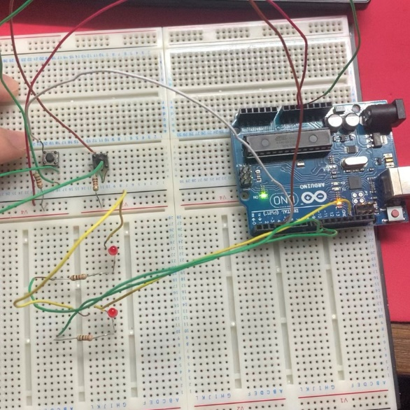

**Coding:**

void setup() {

pinMode(2,INPUT);

pinMode(3,INPUT);

pinMode(8,OUTPUT);

pinMode(9,OUTPUT);

}

void loop() {

bool SW1 = digitalRead(2); //Boolean

bool SW2 = digitalRead(3); //Boolean

if(SW1 == 1){

digitalWrite(8,HIGH); //LED ON

}

else {

digitalWrite(8,LOW); //LED OFF

}

if(SW2 == 1) {

digitalWrite(9,HIGH); //LED ON

}

else {

digitalWrite(9,LOW); //LED OFF

}

}

**Result:**

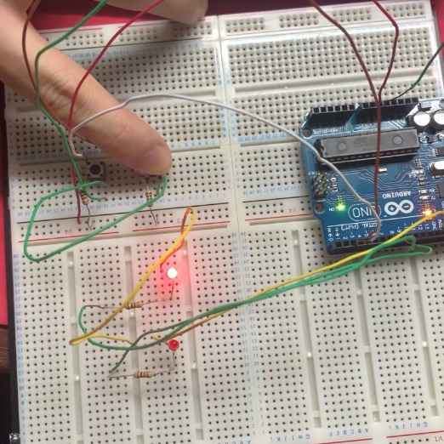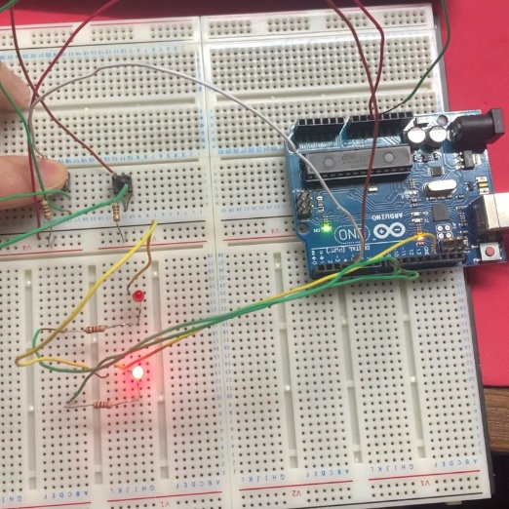

**Figure 3.3.1: LED 1 Figure 3.3.2: LED 2**

**Example 3.3Extra: Active High connection switch**

*Use DDRx, PORTx, and PINx

* Press SW1 (pin 2): Active high LED1(Pin8) On
  + Un-Press SW1: Active high LED1(Pin8) Off
* Press SW2 (pin 3): Active high LED2(Pin9) On
  + Un-Press SW2: Active high LED2(Pin9) Off
* Press SW3 (pin 4): Active high LED3(Pin10) On
  + Un-Press SW3: Active high LED3(Pin10) Off
* Press SW4 (pin 5): Active high LED4(Pin11) On
  + Un-Press SW4: Active high LED4(Pin8) Off

**Diagram:**



**Coding:**

void setup() {

DDRD &=~(0x0C); //Declare as Input

DDRB |= 0x03; //Declare as Output

}

void loop() {

bool SW1 = PIND & 0x04;

bool SW2 = PIND & 0x08;

if(SW1 == 1) {

PORTB |= (0x01); //Force 1

}

else {

PORTB &= ~(0x01); //Force 0

}

if(SW2 == 1) {

PORTB |= (0x02); //Force 1

}

else {

PORTB &= ~(0x02); //Force 0

}

}

**Result**

Similarly to Figure 2.7.1-2.7.10

**Example 3.4: Active High connection DIP SW**

*Use DDRx, PORTx, and PINx

SW1 = PIN2, SW2 = PIN3, SW3 = PIN4, SW4 = PIN5 •

* Toggle SW1: AH-LED1 (Pin8 only) On
* Toggle SW12: AH-LED2 (Pin9 only) On
* Toggle SW123: AH-LED3 (Pin10 only) On
* Toggle SW1234: AH-LED4 (Pin11 only) On
* Other conditions: AH-ALL LEDs Off

**Diagram:**

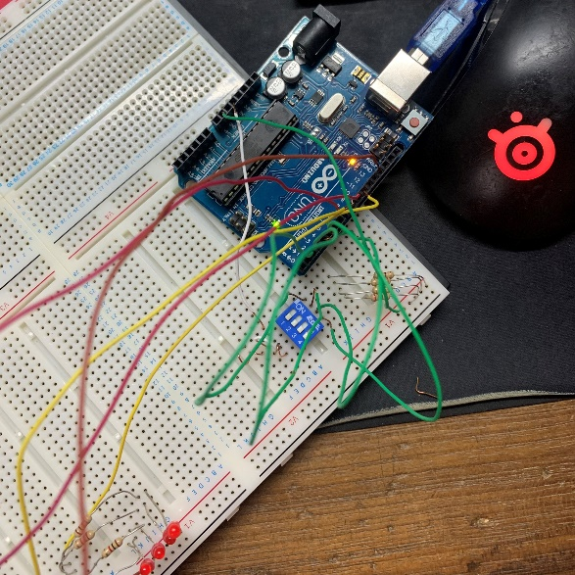

**Coding:**

void setup() {

DDRD &=~(0x1E); //Declare as Input

DDRB |= 0x0F; //Declare as Output

}

void loop() {

bool SW1 = PIND & 0x04;

bool SW2 = PIND & 0x08;

bool SW3 = PIND & 0x10;

bool SW4 = PIND & 0x20;

if(SW1==1 && SW2==0 && SW3==0 && SW4==0) {

PORTB = 0x01;

}

if(SW1==1 && SW2==1 && SW3==0 && SW4==0) {

PORTB = 0x02;

}

if(SW1==1 && SW2==1 && SW3==1 && SW4==0) {

PORTB = 0x04;

}

if(SW1==1 && SW2==1 && SW3==1 && SW4==1) {

PORTB = 0x08;

}

else {

PORTB = 0x00;

}

}

**Result:**

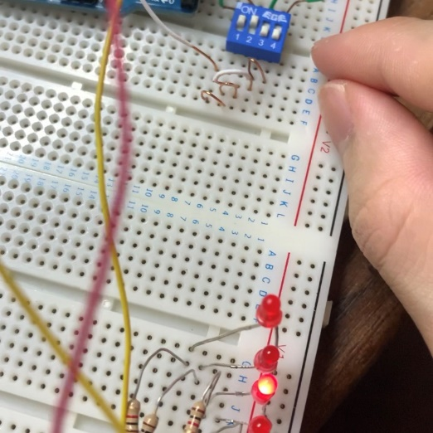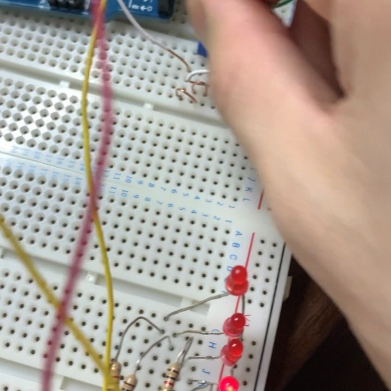

**Figure 3.3.1: LED 1 Figure 3.3.2: LED 2**

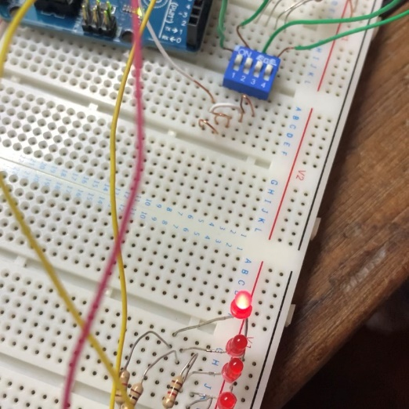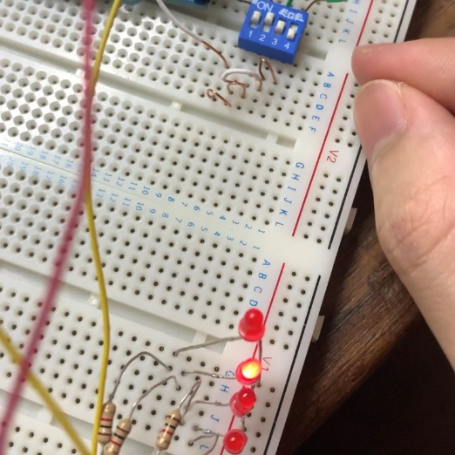

**Figure 3.3.1: LED 3 Figure 3.3.2: LED 4**

**Conclusion:**

In chapter three, a digital input of Arduino was introduced. A digital input is a device that can obtain input from physical action and direct a signal (as o or 1) into Arduino board in order to trigger some further actions to the output. For instance, switches (pushbutton switch and DIP switch). The chapter includes a constant use of if-else function to cause change in output as input is received. There are also 2 kind of connections: Active High and Low similarly to LEDs. AH attaches a digital input pin with the ground line. When the switch is pushed, it allows the current to flow from 5V. AL works on the other way round, by being attached to the 5V line. When the switch is pushed, the current flows to ground.

**CHAPTER 4: SERIAL COMMUNICATION**

**Example 4.1: Reading inputs data with serial monitor**

* Connect AH-DIP SW as inputs (Port D pin 2 – 5 or Port B pin 8 – 11)
* Reading All Bit data through serial communication

**Diagram:**

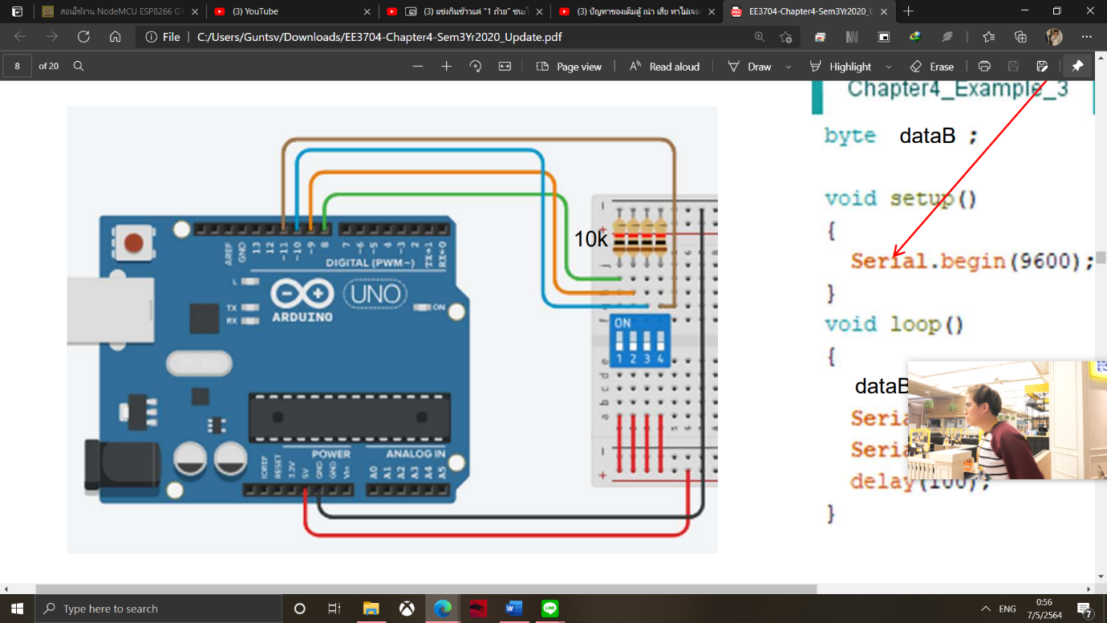

**Coding:**

void setup() {

Serial.begin(9600);

DDRD &=~(0x0c); //Declare as Input

}

void loop() {

unsigned int Data = (PIND)>>2 ; //as Pin 0 and Pin 1 doing communication

Serial.print(" DIP SW data is : ");

Serial.println(Data);

delay(1000);

}

**Result:**

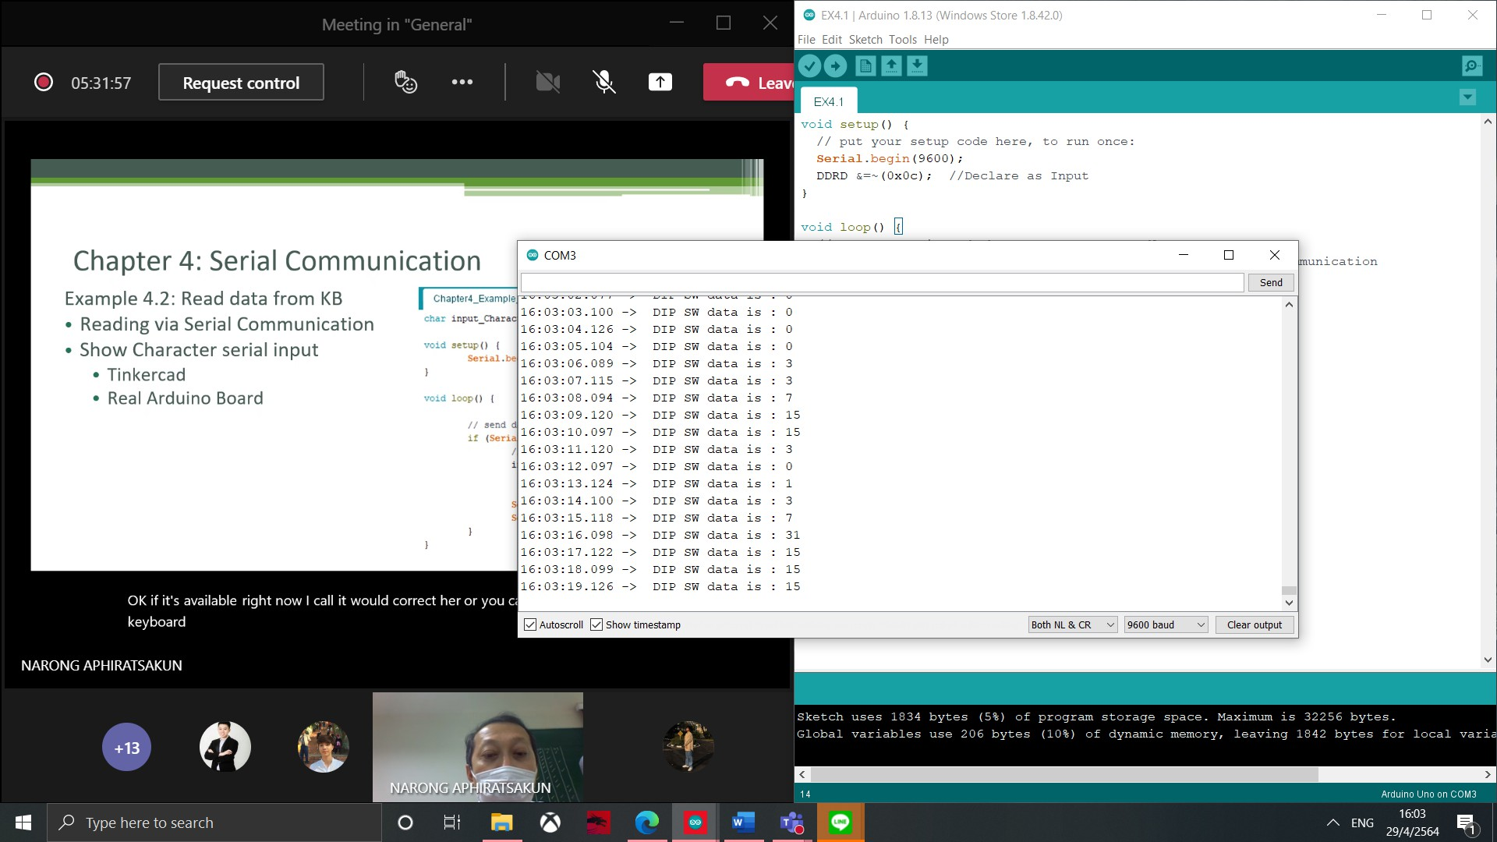

**Figure 4.1.1: INPUT DATA SW 1-4**

**Example 4.2: Read data from KB**

* Reading via Serial Communication
* Show Character serial input

**Diagram:**

No Diagram provide

**Coding:**

void setup() {

Serial.begin(9600);

DDRD |= (0x3c); //Pin2,3,4,5

}

void loop() {

if(Serial.available()>0) {

char KBD = Serial.read();

Serial.print("Number Read as :");

Serial.println(KBD);

delay(1000);

}

}

**Result:**

Number Read as: 0

Number Read as: 1

Number Read as: 2

Number Read as: 3

Number Read as: 4

Number Read as: 5

Number Read as: 6

Number Read as: 7

Number Read as: 8

Number Read as: 9

Number Read as: 10

Number Read as: 11

Number Read as: 12

Number Read as: 13

Number Read as: 14

Number Read as: 15

**Example 4.3: Reading data from KB and control LEDs (use switch-case)**

LEDs are connected at Pins 2,3,4,5 or 8,9,10,11

* Press “1” from keyboard AH-LED1 ON (only) show “LED1 is on” in monitor.
* Press “2” from keyboard AH-LED2 ON (only) show “LED2 is on” in monitor.
* Press “3” from keyboard AH-LED3 ON (only) show “LED3 is on” in monitor.
* Press “4” from keyboard AH-LED4 ON (only) show “LED4 is on” in monitor.
* Press other characters, Reset all AH-LED to OFF
* Show your circuit diagram, coding, and results.

**Diagram:**

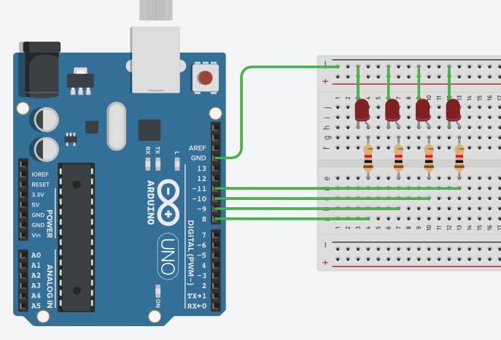

**Coding:**

void setup() {

Serial.begin(9600);

DDRD |= (0x3c); //Pin2,3,4,5

}

void loop() {

if(Serial.available()>0) {

char KBD = Serial.read();

switch(KBD)

{

case '1' :

Serial.println("1: LED1 is ON");

PORTB = 0x01;

break;

case '2':

Serial.println("2: LED2 is ON");

PORTB = 0x02;

break;

case '3':

Serial.println("3: LED3 is ON");

PORTB = 0x04;

break;

case '4':

Serial.println("4: LED4 is ON");

PORTB = 0x08;

break;

default:

PORTB = 0x00;

Serial.println("Others: LEDs are OFF");

break;

}

}

}

**Result:**

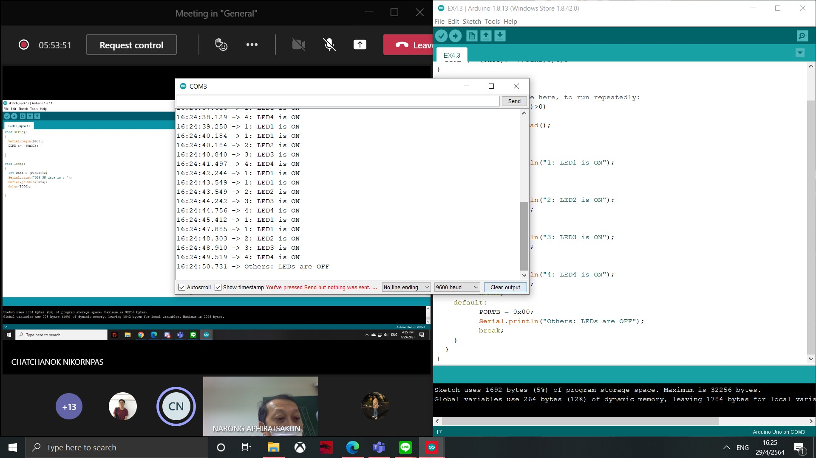

**Figure 4.3.1: INPUT DATA SW 1-4**

**Example 4.4: Use Buzzer/Speaker as output to create music note**

* Press “d” from keyboard produce “Do”
* Press “r” from keyboard produce “Re”
* Press “m” from keyboard produce “Mi”
* Press “f” from keyboard produce “Fa”
* Press “z” from keyboard produce “Zol”
* Press “l” from keyboard produce “La”
* Press “t” from keyboard produce “Ti”
* Show Circuit diagram / and Coding**.**

**Diagram:**

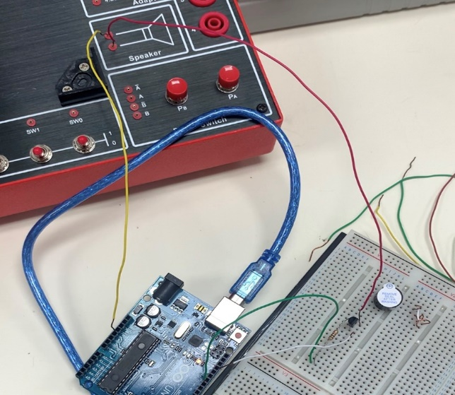

**Coding:**

void setup() {

Serial.begin(9600);

pinMode(10,OUTPUT);

}

void loop() {

if(Serial.available()>0)

{

char KBD = Serial.read();

switch(KBD)

{

case '1' :

case 'd' :

Serial.println("DO");

for(int x = 0 ; x<500 ; x++) {

digitalWrite(10, HIGH);

delayMicroseconds(478);

digitalWrite(10, LOW);

delayMicroseconds(478);

}

delay(100);

break;

case '2' :

case 'r' :

Serial.println("RE");

for(int x = 0 ; x<500 ; x++) {

digitalWrite(10, HIGH);

delayMicroseconds(426);

digitalWrite(10, LOW);

delayMicroseconds(426);

}

delay(100);

break;

case '3' :

case 'm' :

Serial.println("ME");

for(int x = 0 ; x<500 ; x++) {

digitalWrite(10, HIGH);

delayMicroseconds(379);

digitalWrite(10, LOW);

delayMicroseconds(379);

}

delay(100);

break;

case '4' :

case 'f' :

Serial.println("FA");

for(int x = 0 ; x<500 ; x++) {

digitalWrite(10, HIGH);

delayMicroseconds(358);

digitalWrite(10, LOW);

delayMicroseconds(358);

}

delay(100);

break;

case '5' :

case 'z' :

Serial.println("SO");

for(int x = 0 ; x<500 ; x++) {

digitalWrite(10, HIGH);

delayMicroseconds(319);

digitalWrite(10, LOW);

delayMicroseconds(319);

}

delay(100);

break;

case '6' :

case 'l' :

Serial.println("LA");

for(int x = 0 ; x<500 ; x++)

{

digitalWrite(10, HIGH);

delayMicroseconds(284);

digitalWrite(10, LOW);

delayMicroseconds(284);

}

delay(100);

break;

case '7' :

case 't' :

Serial.println("TI");

for(int x = 0 ; x<500 ; x++)

{

digitalWrite(10, HIGH);

delayMicroseconds(253);

digitalWrite(10, LOW);

delayMicroseconds(253);

}

delay(100);

break;

default:

digitalWrite(10, LOW);

break;

}

}

}

**Result:**

There is a keyboard sound.

**Example 4.5: Random LED game when SW is pressed**

**LED pins 2-9, Buzzer pin 10, SW pin 11;

* Make 8 LEDs (AL) go incrementally with fastest speed (example 10ms)
* When a SW is Pressed, a random number is calculated and show on a LED randomly, a buzzer sound is audible for 1s
* LED is on for 3s and go off
* Loop is keep repeating

**Diagram:**

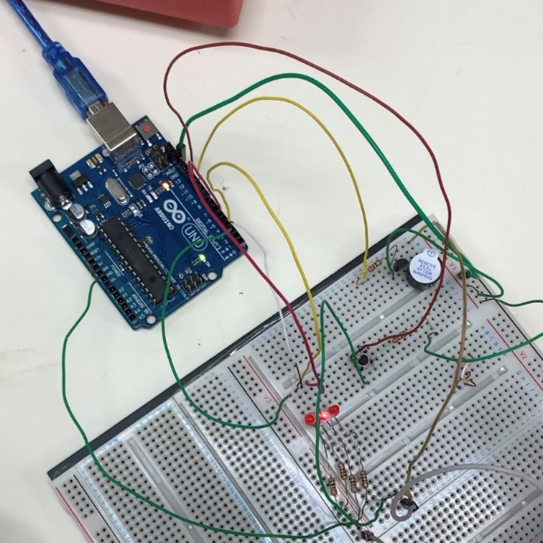

**Coding:**

void setup() {

Serial.begin(9600);

for(int pin=2; pin<6; pin++) {

pinMode(pin,OUTPUT);

}

pinMode(11,INPUT);

pinMode(10,OUTPUT);

Serial.println("Welcome to Game Show");

}

void loop() {

bool SW;

SW = digitalRead(11);

if(SW) {

int number = random(2,6);

Serial.print("Number is :");

Serial.println(number);

digitalWrite(number, LOW);

digitalWrite(10, HIGH);

delay(1000);

digitalWrite(10, LOW);

delay(2000);

}

else {

for(int pin=2; pin<6; pin++) {

digitalWrite(pin, LOW);

delay(10);

digitalWrite(pin, HIGH);

delay(10);

}

}

}

**Result:**

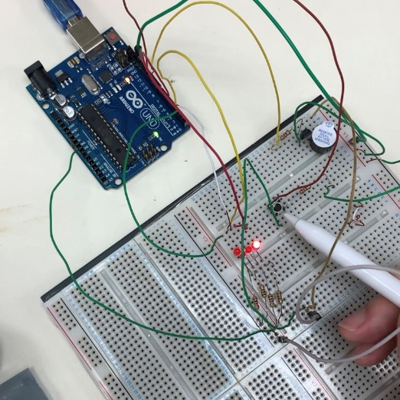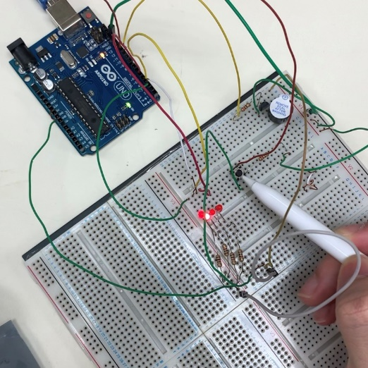

**Figure 4.5.1: LED RANDOM Figure 4.5.2: LED RANDOM**

**Example 4.6:**

**Random LED game when SW is pressed (with higher random range)**

* From Example 4.5, make random number between 0-100.
* Separate 0-100 range into 8 slots for LED with 1st LED of highest odds, and 8th LED of lowest odds. Other LEDs can be your own choice.

**Diagram:**



**Coding:**

void setup() {

Serial.begin(9600);

for(int pin=2; pin<6; pin++) {

pinMode(pin,OUTPUT);

}

pinMode(11,INPUT);

pinMode(10,OUTPUT);

Serial.println("Welcome to Game Show");

}

void loop() {

bool SW;

SW = digitalRead(11);

if(SW) {

int number = random(0,100);

Serial.print("The number is : ");

Serial.println(number);

switch(number)

{

case 0 ... 70 :

Serial.println("pin1");

digitalWrite(10, HIGH);

digitalWrite(2, LOW);

delay(1000);

digitalWrite(2, HIGH);

delay(2000);

digitalWrite(10, LOW);

break;

case 71 ... 85 :

Serial.println("pin2");

digitalWrite(3, LOW);

delay(1000);

digitalWrite(3, HIGH);

delay(2000);

digitalWrite(10, LOW);

break;

case 86 ... 98 :

Serial.println("pin3");

digitalWrite(10, HIGH);

digitalWrite(4, LOW);

delay(1000);

digitalWrite(4, HIGH);

delay(2000);

digitalWrite(10, LOW);

break;

case 99 ... 100 :

Serial.println("pin4");

digitalWrite(10, HIGH);

digitalWrite(5, LOW);

delay(1000);

digitalWrite(5, HIGH);

delay(2000);

digitalWrite(10, LOW);

break;

}

}

else {

for(int pin=2; pin<6; pin++) {

digitalWrite(pin, LOW);

delay(10);

digitalWrite(pin, HIGH);

delay(10);

}

}

}

**Result:**

Similarly to Figure 4.5.1-4.5.2

**Conclusion:**

In chapter four, a serial communication of Arduino was introduced. It can be used to read a desired value as well as to input a value itself for triggering. The baud rate use was fixed to 9600 baud rate, and switch case function was being used for the ease of coding regarding serial communication. Additionally, a buzzer device was being introduced to generate a music note which as well introduced the use of sub void function.

**CHAPTER 5: ANALOG INPUT**

**Example 5.1: With Potentiometer**

* Read the Value from Analog port (Pin A0 )
* 0 to 5 V (10bit ADC)

Serial Monitor will Show between

* 0 V = 0
* 5 V = 102

**Diagram:**

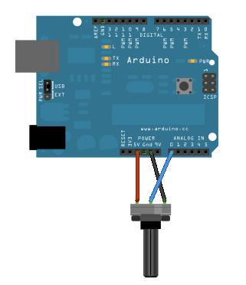

**Coding:**

int Analog_Input_value;

void setup() {

pinMode(A0,INPUT);

Serial.begin(9600);

}

void loop() {

Analog_Input_value = analogRead(A0);

Serial.println(Analog_Input_value);

delay(100);

}

**Result:**

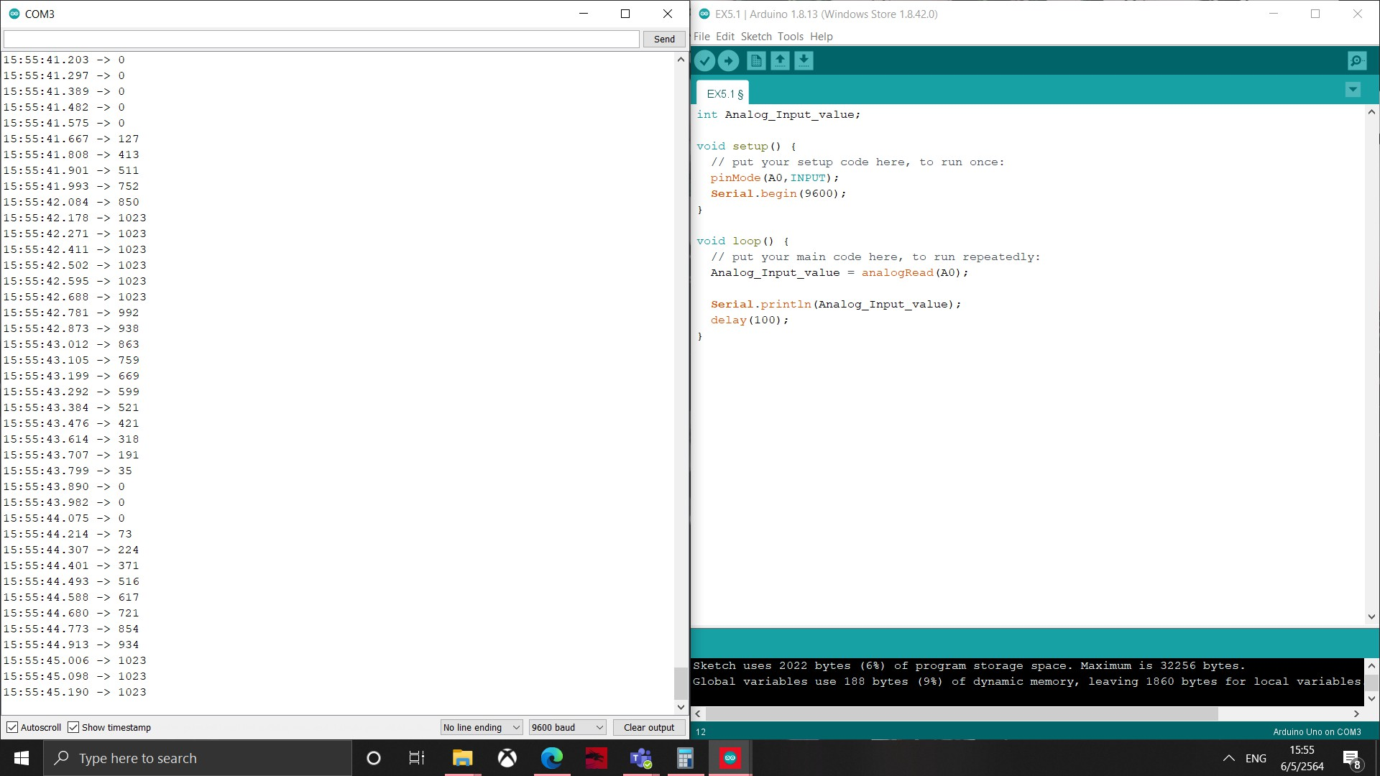

**Figure 5.1.1: DATA**

**Example 5.2: Perform LED operation when Analog data is as follow**

* Analog Input (A0)
  + Value 0 - 255 : only AH-LED1 ON (Pin2)
  + Value 256 - 511 : only AH-LED2 ON (Pin3)
  + Value 512 - 767 : only AH-LED3 ON (Pin4)
  + Value 768 - 1023 : only AH-LED4 ON (Pin5)
* Show circuit diagram, Coding, results (LEDs and serial data of analog value)

**Diagram:**

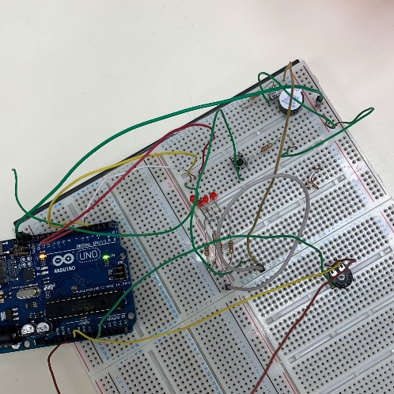

**Coding:**

int Analog_Input_value;

void setup() {

Serial.begin(9600);

pinMode(A0,INPUT);

for(int pin=2; pin<6; pin++) {

pinMode(pin,OUTPUT);

}

}

void loop() {

Analog_Input_value = analogRead(A0);

Serial.print(Analog_Input_value);

delay(100);

switch(Analog_Input_value){

case 0 ... 255 :

Serial.println("pin1");

digitalWrite(2, LOW);

digitalWrite(3, HIGH);

digitalWrite(4, HIGH);

digitalWrite(5, HIGH);

break;

case 256 ... 511 :

Serial.println("pin2");

digitalWrite(2, HIGH);

digitalWrite(3, LOW);

digitalWrite(4, HIGH);

digitalWrite(5, HIGH);

break;

case 512 ... 767 :

Serial.println("pin3");

digitalWrite(2, HIGH);

digitalWrite(3, HIGH);

digitalWrite(4, LOW);

digitalWrite(5, HIGH);

break;

case 768 ... 1023 :

Serial.println("pin4");

digitalWrite(2, HIGH);

digitalWrite(3, HIGH);

digitalWrite(4, HIGH);

digitalWrite(5, LOW);

break;

default :

digitalWrite(2, HIGH);

digitalWrite(3, HIGH);

digitalWrite(4, HIGH);

digitalWrite(5, HIGH);

break;

}

}

**Result:**

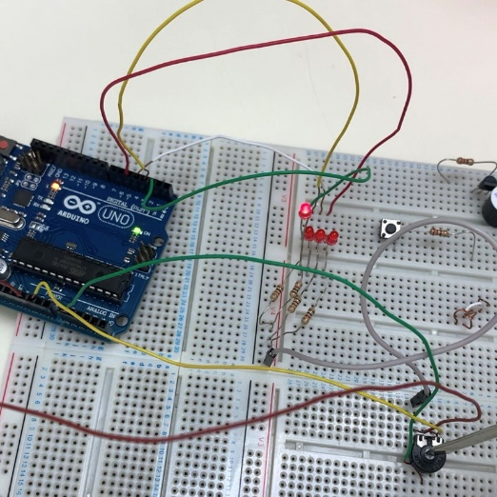

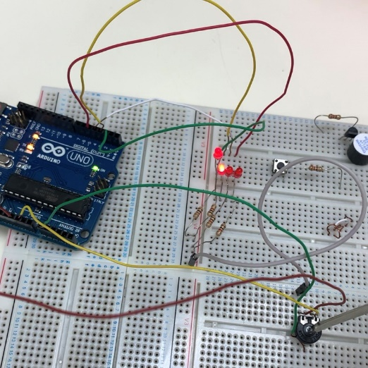

**Figure 5.2.1: LED 1 Figure 5.2.2: LED 2**

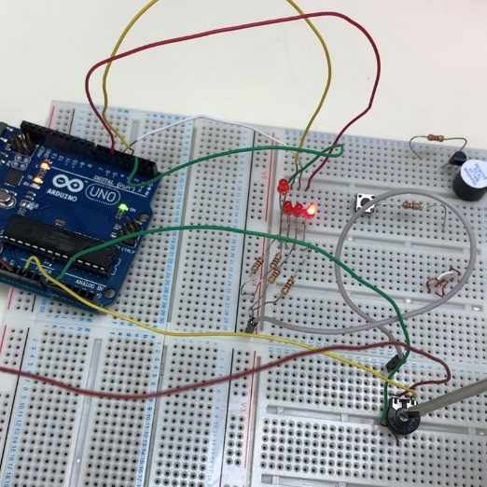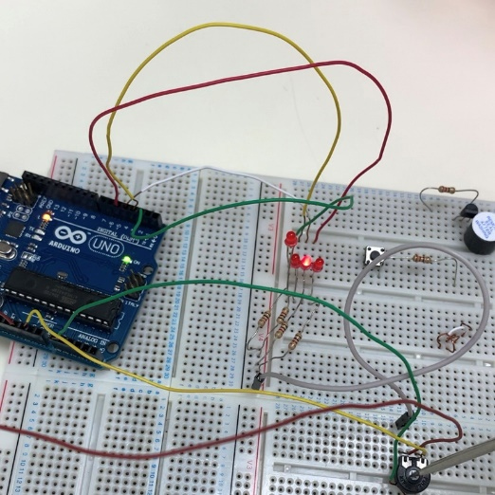

**Figure 5.2.3: LED 3 Figure 5.2.4: LED 4**

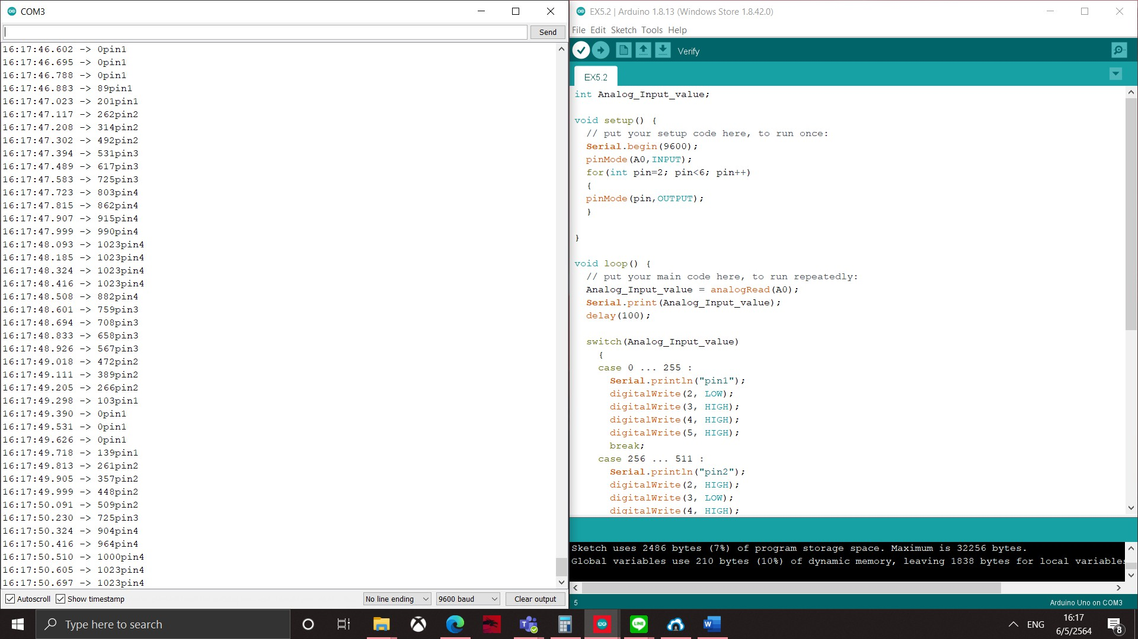

**Figure 5.2.5: DATA**

**Example 5.3: Perform LED operation when Analog data from LDR is**

* LDR is at A0
  + Light is bright : (AH) LED1 ON
  + Light is moderate : (AH) LED1 and LED2 ON
  + Light is dim : (AH) LED1, LED2 and LED3 ON

*AL-LEDS: Pin 2,3,4

* Show circuit diagram, Coding, results (LEDs and serial data of analog value)

**Diagram:**

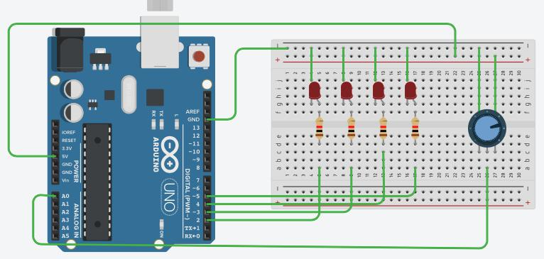

**Coding:**

int Analog_Input_value;

void setup() {

Serial.begin(9600);

pinMode(A0,INPUT);

for(int pin=2; pin<6; pin++) {

pinMode(pin,OUTPUT);

}

}

void loop() {

Analog_Input_value = analogRead(A0);

Serial.print(Analog_Input_value);

delay(100);

switch(Analog_Input_value){

case 601 ... 1000 :

Serial.println("pin1");

digitalWrite(2, LOW);

digitalWrite(3, HIGH);

digitalWrite(4, HIGH);

break;

case 401 ... 600 :

Serial.println("pin2");

digitalWrite(2, HIGH);

digitalWrite(3, LOW);

digitalWrite(4, HIGH);

break;

case 0 ... 400 :

Serial.println("pin3");

digitalWrite(2, HIGH);

digitalWrite(3, HIGH);

digitalWrite(4, LOW);

break;

default :

digitalWrite(2, HIGH);

digitalWrite(3, HIGH);

digitalWrite(4, HIGH);

break;

}

}

**Result:**

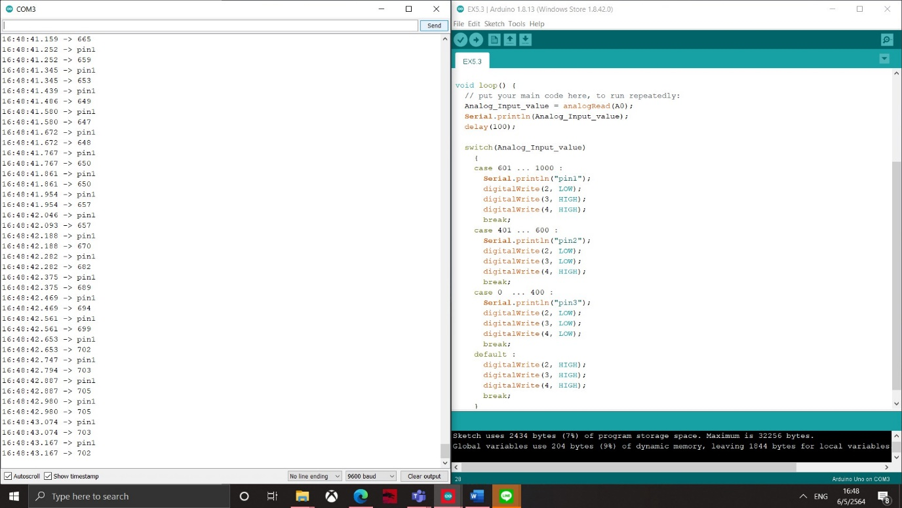

**Figure 5.3.1: DATA**

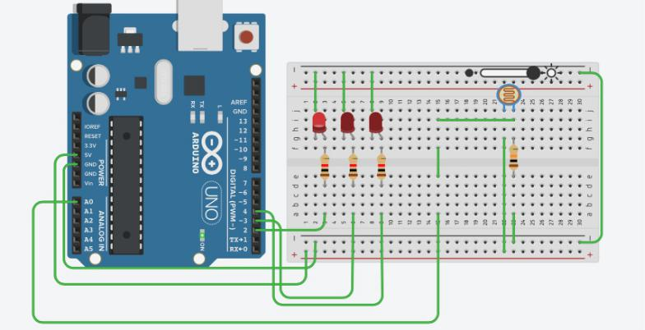

**Figure 5.3.2: Full Light Condition**

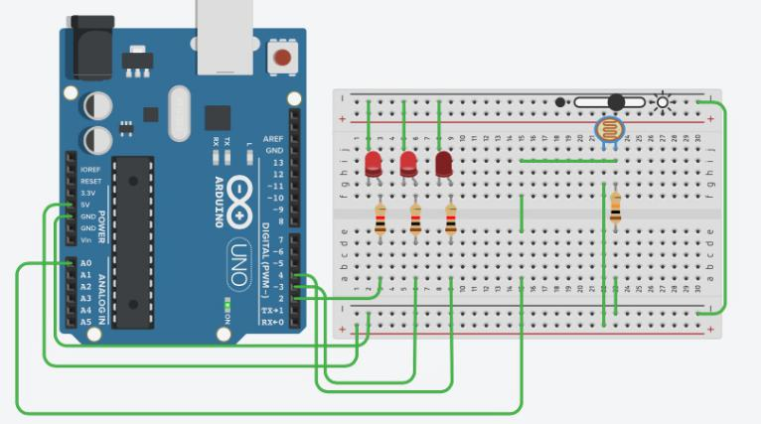

**Figure 5.3.3: Moderate Light Condition**

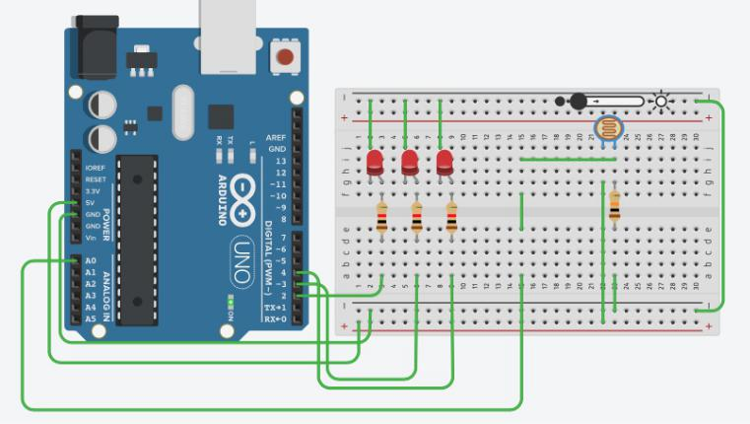

**Figure 5.3.4: Dim to No Light Condition**

**Conclusion:**

In chapter five, an analog input of Arduino was introduced. In this course, a potentiometer and LDR device were used. A potentiometer is a device that can vary it resistance value (0 -1023 Ohms) by the rotator, where LDR is as well a variable resistance that can be altered based on the amount of light it receives. Therefore, each condition of resistance value can be written to perform different actions, turn on LEDs for example.

**CHAPTER 6: PULSE WIDTH MODULATION (PWM)**

**Example 6.1:**

* Use PIN 5 as PWM • Measure with oscilloscope
* Set duty cycle of PWM = 20%
* Set duty cycle of PWM = 50%
* Set duty cycle of PWM = 75%
* From each duty cycle, measure output voltage from respective duty cycle?
* What is frequency of the PWM 1k Hz

**Diagram:**

No diagram provided. Simply measure a particular pin with a probe.

**Coding:**

int Analog_Input_value;

void setup() {

pinMode(5,OUTPUT);

}

void loop() {

analogWrite(5,51); //20%

//analogWrite(5,128); //50%

//analogWrite(5,191); //75% //switch when measures

}

**Result:**

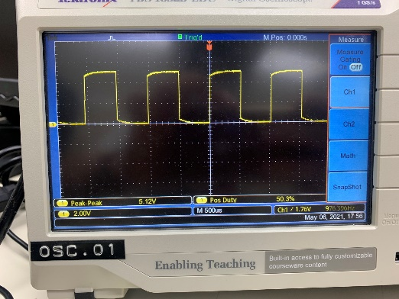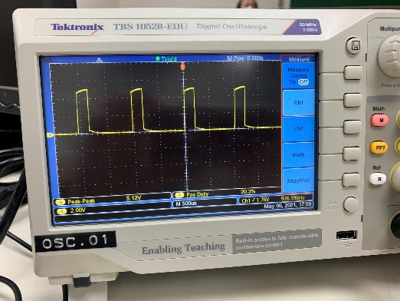

**Figure 6.1.1:** PWM **20% Figure 6.1.2** PWM**: 50%**

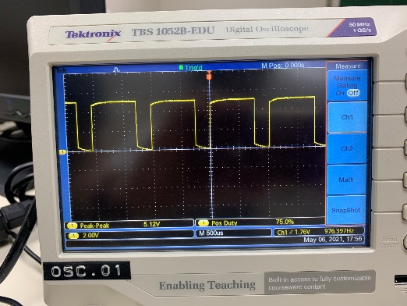

**Figure 6.1.3:** PWM **75%**

**Example 6.2:**

* Use PIN 9 as PWM • Measure with oscilloscope
* Set duty cycle of PWM = 20%
* Set duty cycle of PWM = 50%
* Set duty cycle of PWM = 75%
* From each duty cycle, measure output voltage from respective duty cycle?
* What is frequency of the PWM 500 Hz

**Diagram:**

No diagram provided. Simply measure a particular pin with a probe.

**Coding:**

int Analog_Input_value;

void setup() {

pinMode(9,OUTPUT);

}

void loop() {

analogWrite(9,51); //20%

//analogWrite(9,128); //50%

//analogWrite(9,191); //75% //switch when measures

}

**Result:**

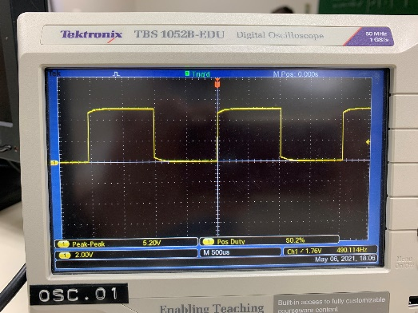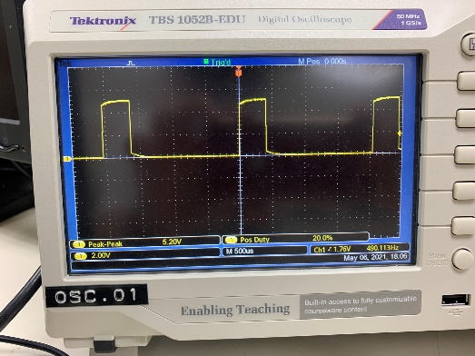

**Figure 6.2.1:** PWM **20% Figure 6.2.2** PWM**: 50%**

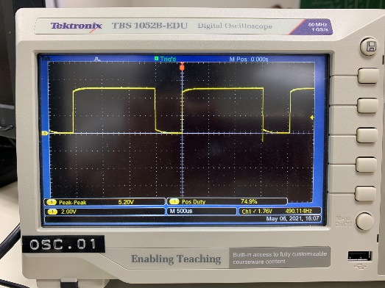

**Figure 6.2.3:** PWM **75%**

**Example 6.3:**

Control duty cycle of PWM with DIP SW (active high connection), use switchingfrequency as 500 Hz.

* Press Sw1 : AH-LED1 Blink 25%, PWM data show in serial and measure analog voltage output from multimeter
* Press Sw2 : AH-LED1 Blink 50%, PWM data show in serial and measure analog voltage output from multimeter
* Press Sw3 : AH-LED1 Blink 75%, PWM data show in serial and measure analog voltage output from multimeter
* Press Sw4 : AH-LED1 Blink 100%, PWM data show in serial and measure analog voltage output from multimeter
* Others : AH-LED1 OFF
* Show Circuit diagram, Coding, results (with LEDs and serial data)

**Diagram:**

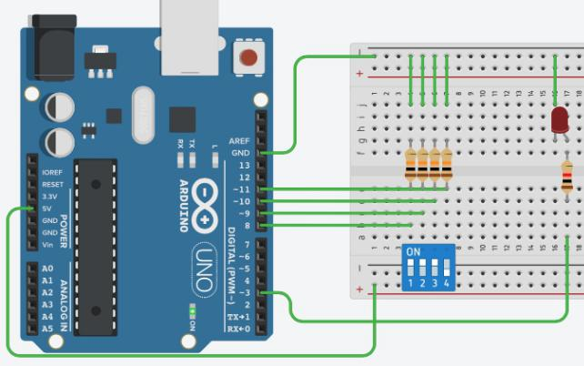

**Coding:**

void setup() {

Serial.begin(9600);

for(int a=8;a<12;a++) {

pinMode(a, INPUT);

}

pinMode(3, OUTPUT);

}

void loop() {

bool SW1 = digitalRead(8);

bool SW2 = digitalRead(9);

bool SW3 = digitalRead(10);

bool SW4 = digitalRead(11);

if(SW1==1 && SW2==0 && SW3==0 && SW4==0){

analogWrite(3,64); //25%

Serial.print("SW1:");

Serial.println(" Blink PWM 25%");

}

else if(SW1==0 && SW2==1 && SW3==0 && SW4==0){

analogWrite(3,128); //50%

Serial.print("SW2:");

Serial.println(" Blink PWM 50%");

}

else if(SW1==0 && SW2==0 && SW3==1 && SW4==0){

analogWrite(3,191); //75%

Serial.print("SW3:");

Serial.println(" Blink PWM 75%");

}

else if(SW1==0 && SW2==0 && SW3==0 && SW4==1) {

analogWrite(3,255); //100%

Serial.print("SW4:");

Serial.println(" Blink PWM 100%");

}

else {

analogWrite(3,0);

}

delay(100);

}

**Result:**

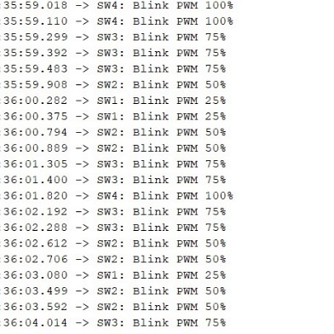

**Figure 6.3.1:** Serial Monitor

**Example 6.4:**

Control duty cycle of PWM with analog reading

• Analog read XX %: AH-LED1 Blink XX%, analog reading value show in serial monitor as percentage

• Example xx = 10% ▫ Analog read 10 %: AH-LED1 Blink 10%, analog reading value show in serial monitor as percentage

• Show Circuit diagram, Coding, results (with LEDs and serial data)

**Diagram:**

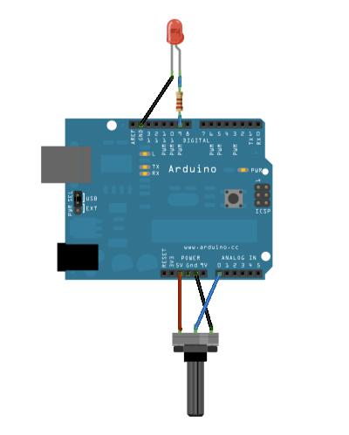

**Coding:**

void setup() {

Serial.begin(9600);

pinMode(9, OUTPUT);

}

void loop() {

int Analog_Input_value1,Analog_Input_value2,percent;

Analog_Input_value1 = analogRead(A0);

Analog_Input_value2 = Analog_Input_value1/4; // From 1023 >> 255

percent = (Analog_Input_value2*100)/255;

analogWrite(9,Analog_Input_value2);//0-255

Serial.print("Blink PWM ");

Serial.print(percent);

Serial.println(" %");

}

**Result:**

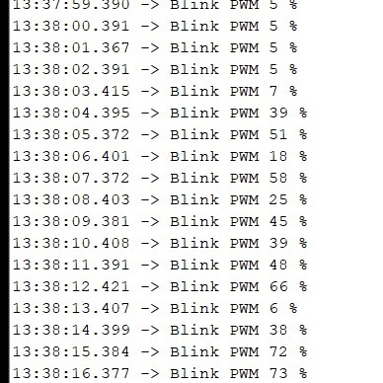

**Figure 6.4.1:** Serial Monitor

**Example 6.5 :**

• Use PIN 5 as PWM

• Set Pulse Width to 50%

• Set divisor to 8, measure the waveform

• Set divisor to 256, measure the waveform

• What is frequency of the PWM for each divisor

divisor is 8, PWM = 62500/8 = 7.8 kHz

divisor is 256, PWM = 62500/256 = 244 kHz

**Diagram:**

No diagram provided. Simply measure a particular pin with a probe.

**Coding:**

void setup() {

//setPwmFrequency(int pin,divisor);

setPwmFrequency(5,8); //Divisor by 8 --> GOT 7.8 KhZ

//setPwmFrequency(5,256); //Divisor by 256 ->

pinMode(5, OUTPUT);

}

void loop() {

analogWrite(5, 127);

}

void setPwmFrequency(int pin, int divisor) {

byte mode;

if(pin == 5 || pin == 6 || pin == 9 || pin == 10) {

switch(divisor) {

case 1: mode = 0x01; break;

case 8: mode = 0x02; break;

case 64: mode = 0x03; break;

case 256: mode = 0x04; break;

case 1024: mode = 0x05; break;

default: return;

}

if(pin == 5 || pin == 6) {

TCCR0B = TCCR0B & 0b11111000 | mode;

}

else {

TCCR1B = TCCR1B & 0b11111000 | mode;

}

}

else if(pin == 3 || pin == 11) {

switch(divisor) {

case 1: mode = 0x01; break;

case 8: mode = 0x02; break;

case 32: mode = 0x03; break;

case 64: mode = 0x04; break;

case 128: mode = 0x05; break;

case 256: mode = 0x06; break;

case 1024: mode = 0x07; break;

default: return;

}

TCCR2B = TCCR2B & 0b11111000 | mode;

}

}

**Result:**

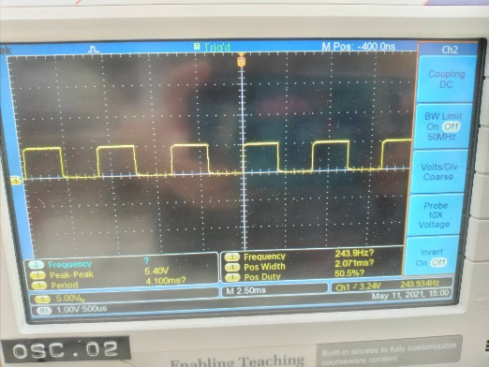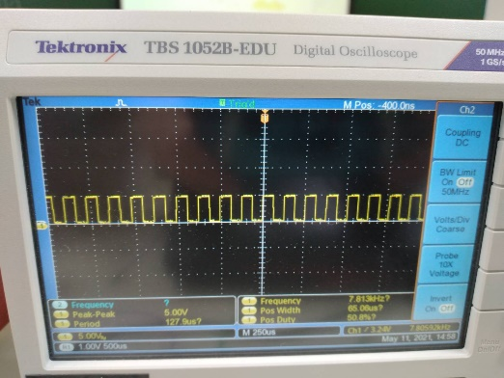

**Figure 6.5.1:** divisor is 8 **Figure 6.5.2** divisor is 256

**Example 6.6:**

• Use PIN 9 as PWM

• Set divisor to 8, measure the waveform

• Set divisor to 256, measure the waveform

• What is frequency of the PWM for each divisor

divisor is 8, PWM = 31250/8 = 3.9 kHz

divisor is 256, PWM = 31250/256 = 122 kHz

**Diagram:**

No diagram provided. Simply measure a particular pin with a probe.

**Coding:**

void setup() {

//setPwmFrequency(int pin,divisor);

setPwmFrequency(9,8); //Divisor by 8 --> GOT 7.8 KhZ

//setPwmFrequency(9,256); //Divisor by 256 ->

pinMode(9, OUTPUT);

}

void loop() {

analogWrite(9, 127);

}

void setPwmFrequency(int pin, int divisor) {

byte mode;

if(pin == 5 || pin == 6 || pin == 9 || pin == 10) {

switch(divisor) {

case 1: mode = 0x01; break;

case 8: mode = 0x02; break;

case 64: mode = 0x03; break;

case 256: mode = 0x04; break;

case 1024: mode = 0x05; break;

default: return;

}

if(pin == 5 || pin == 6) {

TCCR0B = TCCR0B & 0b11111000 | mode;

}

else {

TCCR1B = TCCR1B & 0b11111000 | mode;

}

}

else if(pin == 3 || pin == 11) {

switch(divisor) {

case 1: mode = 0x01; break;

case 8: mode = 0x02; break;

case 32: mode = 0x03; break;

case 64: mode = 0x04; break;

case 128: mode = 0x05; break;

case 256: mode = 0x06; break;

case 1024: mode = 0x07; break;

default: return;

}

TCCR2B = TCCR2B & 0b11111000 | mode;

}

}

**Result:**

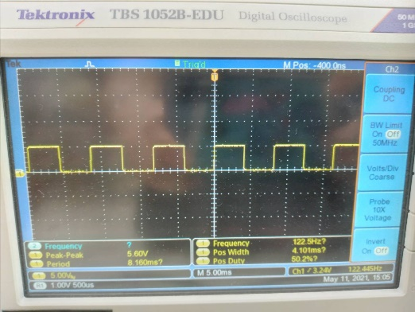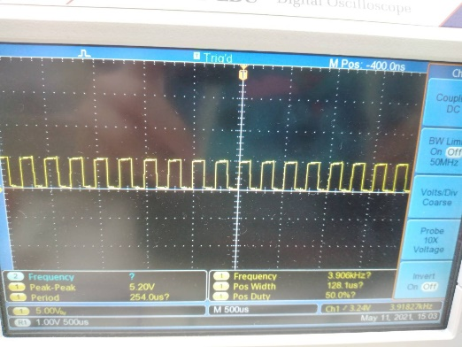

**Figure 6.6.1:** divisor is 8 **Figure 6.6.2** divisor is 256

**Example 6.7:**

* Use RGB module
* Perform RGB LED module as color indicated
* Pin for R ……., Value 0
* Pin for G ……., Value 108
* Pin for B ……., Value 255

**Diagram:**

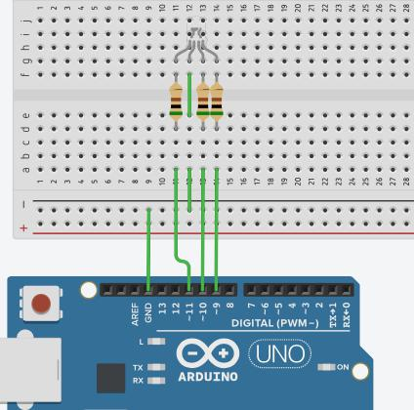

**Coding:**

void setup() {

pinMode(9, OUTPUT); //R

pinMode(10, OUTPUT); //G

pinMode(11, OUTPUT); //B

}

void loop() {

//analogWrite(9, 255-228); //PINK

//analogWrite(10, 255-67);

//analogWrite(11, 255-183);

analogWrite(9, 255-0); //BLUE

analogWrite(10, 255-108);

analogWrite(11, 255-255);

}

**Result:**

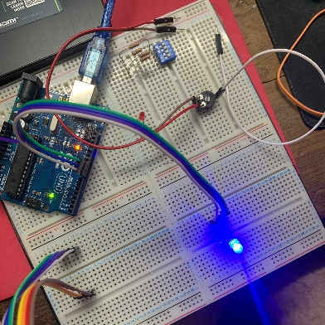

**Figure 6.7.1:** ‘BLUE’ LED

**Example 6.8:**

Speed control of motor • Set f = 3.9 KHz

• Press “a” from KB, set motor 100% CW

• Press “b” from KB, set motor 60% CW

• Press “s” from KB, set motor 0%

• Press “d” from KB, set motor 100% CCW

• Press “e” from KB, set motor 60% CCW

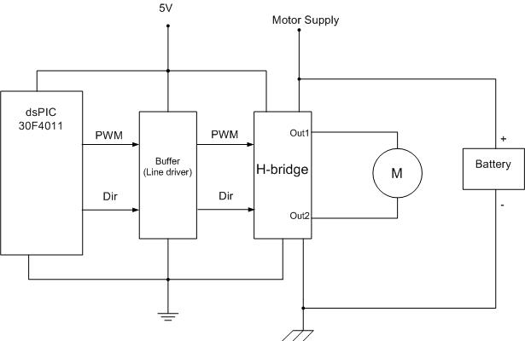**Diagram:**

**Coding:**

void setup()

{

Serial.begin(9600);

pinMode(9,OUTPUT); //PWM

setPwmFrequency(9,8); //Divisor by 8 we get 3.9kHz

pinMode(2,OUTPUT); //DirA

pinMode(3,OUTPUT); //DirB

}

void loop(){

if(Serial.available()>0){

char KBD = Serial.read();

switch(KBD)

{

case 'a':

analogWrite(9,255); //100%

digitalWrite(2, LOW);

digitalWrite(3, HIGH);

Serial.println("A 100%CW");

break;

case 'b':

analogWrite(9,153); //60%

digitalWrite(2, LOW);

digitalWrite(3, HIGH);

Serial.println("B 60%CW");

break;

case 's':

analogWrite(9,0); //0%

digitalWrite(2, LOW);

digitalWrite(3, LOW);

Serial.println("S 0%");

break;

case 'd':

analogWrite(9,255); //100%

digitalWrite(2, HIGH);

digitalWrite(3, LOW);

Serial.println("D 100%CCW");

break;

case 'e':

analogWrite(9,153); //60%

digitalWrite(2, HIGH);

digitalWrite(3, LOW);

Serial.println("E 60%CCW");

break;

}

}

}

void setPwmFrequency(int pin, int divisor) {

byte mode;

if(pin == 5 || pin == 6 || pin == 9 || pin == 10) {

switch(divisor) {

case 1: mode = 0x01; break;

case 8: mode = 0x02; break;

case 64: mode = 0x03; break;

case 256: mode = 0x04; break;

case 1024: mode = 0x05; break;

default: return;

}

if(pin == 5 || pin == 6) {

TCCR0B = TCCR0B & 0b11111000 | mode;

} else {

TCCR1B = TCCR1B & 0b11111000 | mode;

}

} else if(pin == 3 || pin == 11) {

switch(divisor) {

case 1: mode = 0x01; break;

case 8: mode = 0x02; break;

case 32: mode = 0x03; break;

case 64: mode = 0x04; break;

case 128: mode = 0x05; break;

case 256: mode = 0x06; break;

case 1024: mode = 0x07; break;

default: return;

}

TCCR2B = TCCR2B & 0b11111000 | mode;

}

}

**Result:**

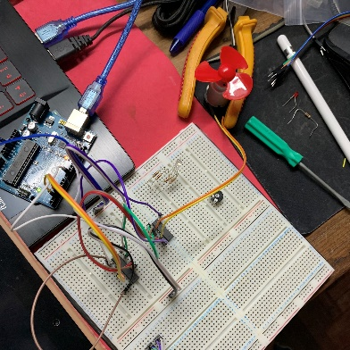

**Figure 6.8.1:** MOTOR

**Conclusion:**

In chapter 6, an analog output of Arduino was introduced. Pulse Width Modulation (PWM) is a method used to vary the frequency of output by causing change to the duty cycle from Arduino. PWM can commonly be found on the Arduino board itself. The symbol can be indicated as “~” in front of the pin numbers that are capable of performing such action. For this case, pin 5 and 6 with 1 kHz of frequency and pin 3, 9, 10, and 11 with 500 Hz of frequency. This can be used through several kind of devices and circuit such as RGB and Fan Control circuit.

**CHAPTER 6.5: PCB DESIGN**

**Result:**

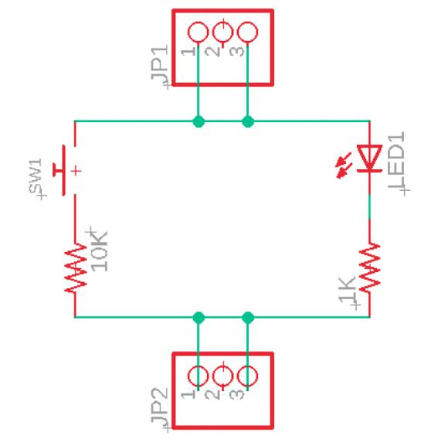

**Figure 0.1: Schematic Design**

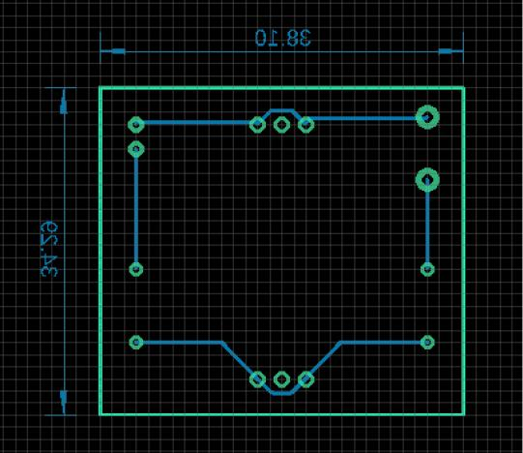

**Figure 0.2: Board Design**

**Result:** (OWN PCB)

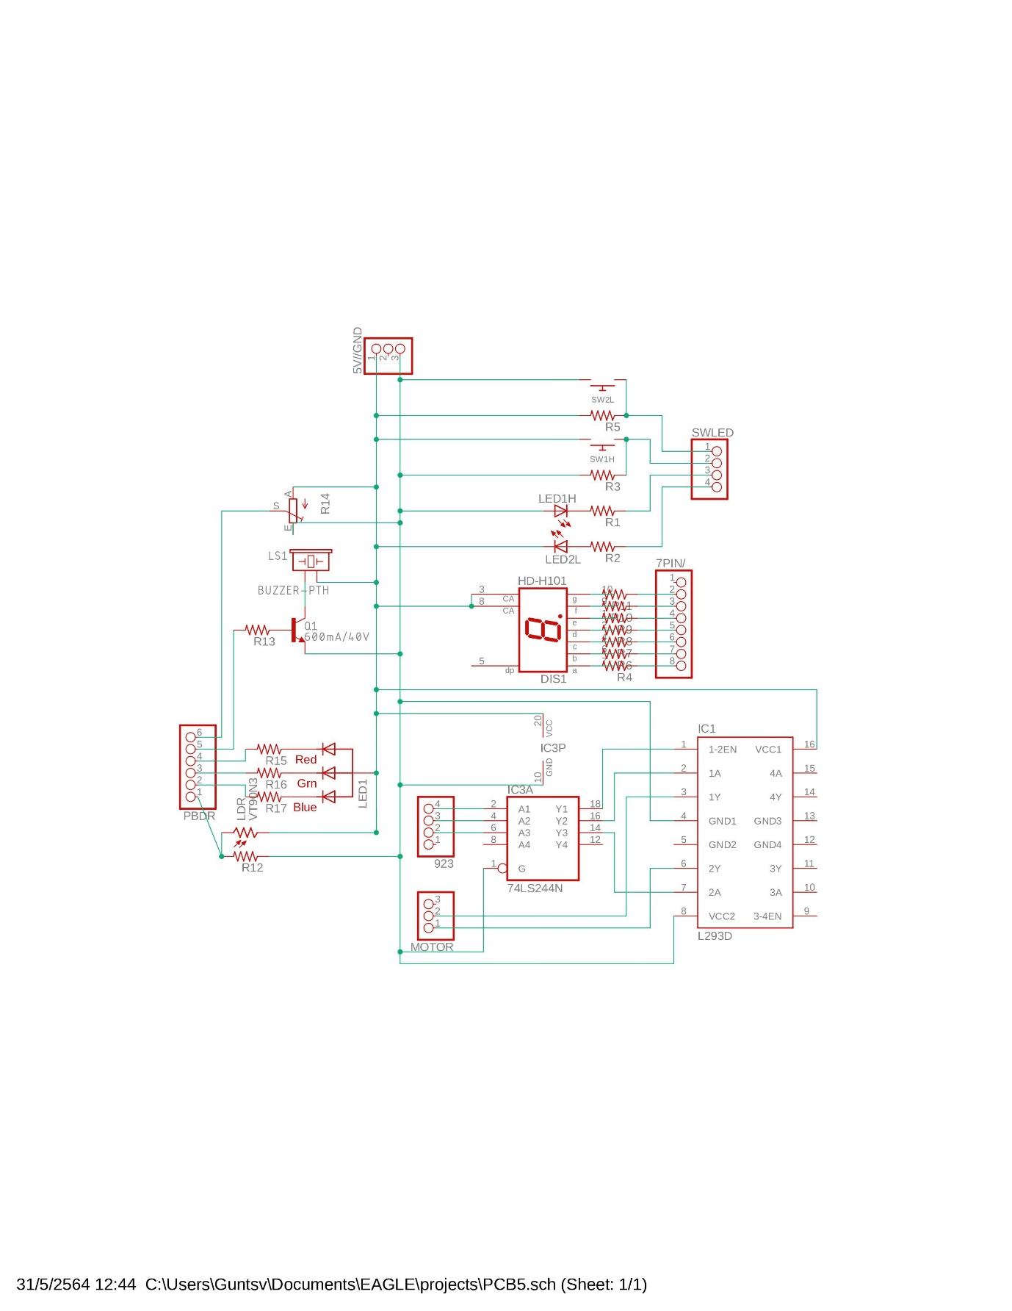

**Figure 0.1: Schematic Design**

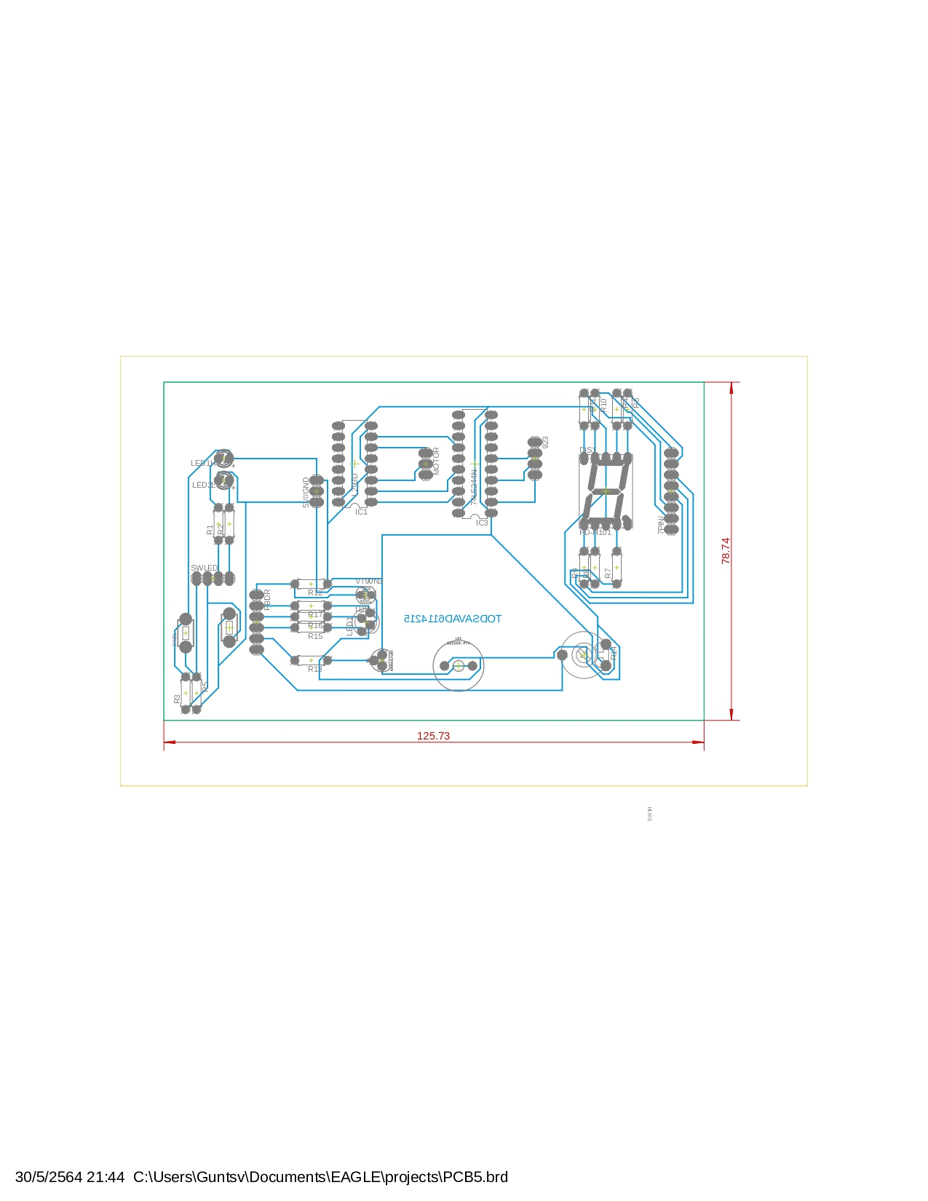

**Figure 0.2: Layout**

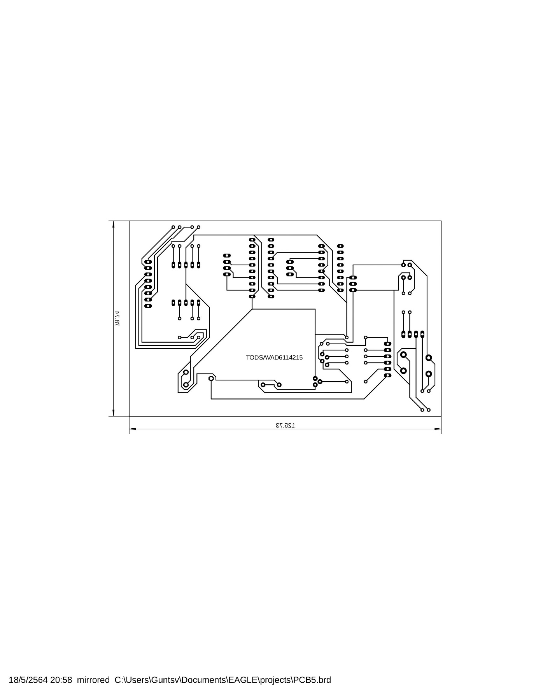

**Figure 0.3: Final Soldered PCB**

**Conclusion:**

In chapter 6.5, a PCB design was introduced by using EAGLE application. A PCB is the use of computer programming as to eliminate wirings and replace them with thin metal plates embedded on a plastic board. The process began with the creation of schematic. In this step, footprint selection was crucial. After assembled all devices into a circuit, board can be generated. However, arrangement is required again on the board before autorouting. This was the most time consuming as it may not be run into a 100% in a first attempt. Some arrangement had to be done additionally to ensure that the metal plates didn't overlap each other causing short circuit to some connection. As soon as the autorouter is made completely, the dimension was created to indicate size of the PCB board. Finally, some layers has to be arranged and mirrored before saving as pdf file.

**CHAPTER 7: Timer and External Interrupt**

**Example 7.1:** Interrupt at 0.5s

* ON buzzer a beep 0.1s for every 0.5s
* Show circuit diagram, Coding, result –
  + Tinkercad –
  + Real Arduino board

**Diagram:**

Similarly to Example 4.4

**Coding:**

void setup()

{

pinMode(12, OUTPUT);

pinMode(13, OUTPUT);

//Initialize Timer

noInterrupts(); //disable all interrupts

//Make a timer as 0.5s

TCCR1A = 0; //timer 1

TCCR1B = 0;

TCNT1 = 0; //clear 0

OCR1A = 31250; //Compare match register 16MHz/256/2Hz

TCCR1B |=(1<<WGM12); //CTC mode

TCCR1B |=(1<<CS12); //256 prescaler

TIMSK1 |=(1<<OCIE1A); //Enable timer compare interrupt

interrupts(); //Enable all interrupts

}

ISR(TIMER1_COMPA_vect)

{

digitalWrite(13,HIGH);

delay(100);

digitalWrite(13,LOW);

}

void loop()

{

digitalWrite(12,HIGH);

delay(2000);

digitalWrite(12,LOW);

delay(2000);

}

**Result:**

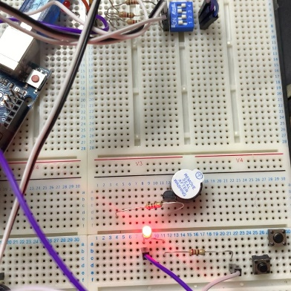

**Figure 7.1.1:** LED ON

**Example 7.2:** Interrupt at 4s

* ON buzzer a beep 0.1s for every 4s
* Show circuit diagram, Coding, result –
  + Tinkercad –
  + Real Arduino board

**Diagram:**

Similarly to Example 4.4

**Coding:**

void setup()

{

pinMode(13, OUTPUT);

//Initialize Timer

noInterrupts(); //disable all interrupts

//Make a timer as 4 s

TCCR1A = 0; //timer 1

TCCR1B = 0;

TCNT1 = 0; //clear 0

OCR1A = 62500; //Set time value

TCCR1B |=(1<<WGM12); // clear timer

TCCR1B |=(1<<CS12);

TCCR1B |=(1<<CS10); //Set prescaler as 1024 TIMSK1 |=(1<<OCIE1A);

TIMSK1 |=(1<<OCIE1A);//Enable timer compare

interrupts(); //Enable interrupts

}

ISR(TIMER1_COMPA_vect)

{

digitalWrite(13,HIGH);

delay(100);

digitalWrite(13,LOW);

delay(100);

}

void loop()

{

digitalWrite(12,HIGH);

delay(2000);

digitalWrite(12,LOW);

delay(2000);

}

**Result:**

Similarly to Figure 7.2.1

**Example 7.3:**

* Running (CC/CA) 7 segment 0 - 9 delay 1 second
* Timer interrupt every 1 second, switch ON Buzzer Pin4 for 0.2s, and switch OFF for 0.8s.
* Show circuit diagram, Coding, result

**Diagram:**

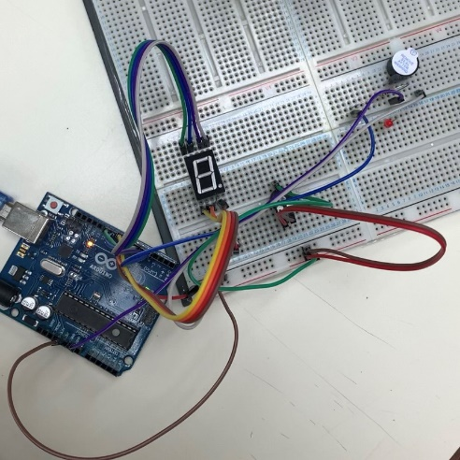

**Coding:**

void setup()

{

pinMode(4, OUTPUT);

for (char i = 5; i<12; i++)

{

pinMode(i, OUTPUT);

}

//Initialize Timer

noInterrupts(); //disable all interrupts

//Make a timer as 1s

TCCR1A = 0; //timer 1

TCCR1B = 0;

TCNT1 = 0; //clear 0

OCR1A = 15625; //Compare match register 16MHz/1024/1Hz

TCCR1B |=(1<<WGM12); //CTC mode

TCCR1B |=(1<<CS12); //256 prescaler

TCCR1B |=(1<<CS10); //1024 prescaler

TIMSK1 |=(1<<OCIE1A); //Enable timer compare interrupt

interrupts(); //Enable all interrupts

}

ISR(TIMER1_COMPA_vect)

{

digitalWrite(4,HIGH);

delay(200);

digitalWrite(4,LOW);

}

void loop() //CA

{

int number_09[10][7] ={{0,0,0,0,0,0,1}, //row0

{1,0,0,1,1,1,1}, //row1

{0,0,1,0,0,1,0}, //row2

{0,0,0,0,1,1,0}, //row3

{1,0,0,1,1,0,0}, //row4

{0,1,0,0,1,0,0}, //row5

{0,1,0,0,0,0,0}, //row6

{0,0,0,1,1,1,1}, //row7

{0,0,0,0,0,0,0}, //row8

{0,0,0,0,1,0,0},};//row9 //a,b,c,d,e,f,g

for (char row=0; row<10; row++)

{

for (char pin=5; pin<12; pin++)

{

digitalWrite(pin, number_09[row][pin-5]);

}

delay(1000);

}

}

**Result:**

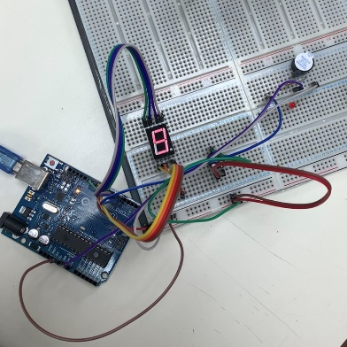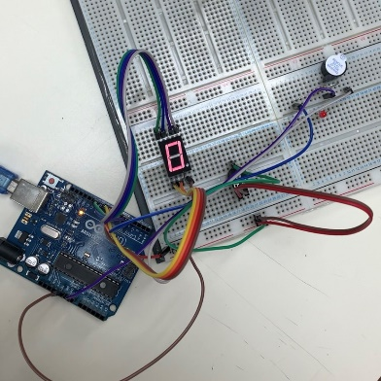

**Figure 7.3.1:** LED ‘0’ until ‘9’ repeatedly with Buzzer On

**Example 7.4:**

* Running (CC/CA) 7 segment 0 - 9 delay 1 second
* If interrupt SW is pressed
  + Buzzer On for short beep (0.2s)
* Show circuit diagram, Coding, result

**Diagram:**

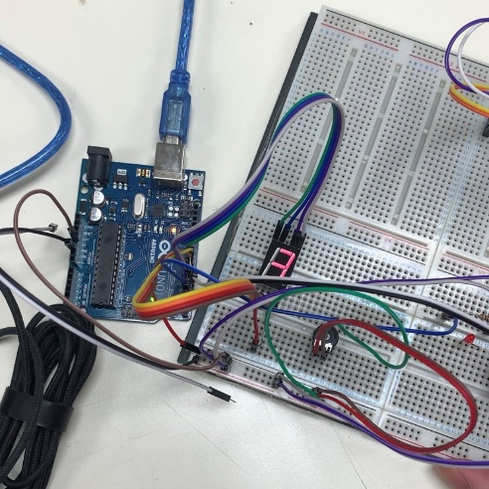

**Coding:**

void blink()

{

digitalWrite(4,HIGH);

delay(200);

digitalWrite(4,LOW);

}

void setup()

{

//attachInterrupt(digitalPinToInterrupt(pin), ISR ,mode);

pinMode(4, OUTPUT);

for (char i = 5; i<12; i++)

{

pinMode(i, OUTPUT);

}

attachInterrupt(digitalPinToInterrupt(2), blink ,RISING);

}

void loop() //CA

{

int number_09[10][7] ={{0,0,0,0,0,0,1}, //row0

{1,0,0,1,1,1,1}, //row1

{0,0,1,0,0,1,0}, //row2

{0,0,0,0,1,1,0}, //row3

{1,0,0,1,1,0,0}, //row4

{0,1,0,0,1,0,0}, //row5

{0,1,0,0,0,0,0}, //row6

{0,0,0,1,1,1,1}, //row7

{0,0,0,0,0,0,0}, //row8

{0,0,0,0,1,0,0},};//row9 //a,b,c,d,e,f,g

for (char row=0; row<10; row++)

{

for (char pin=5; pin<12; pin++)

{

digitalWrite(pin, number_09[row][pin-5]);

}

delay(1000);

}

}

**Result:**

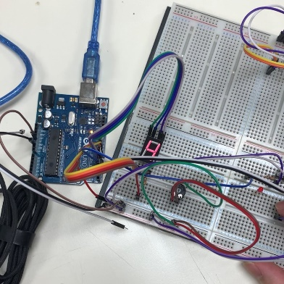

**Figure 7.4.1:** LED ‘0’ until ‘9’ repeatedly

,and Pressing Switch to Buzzer On

**Example 7.5: (For Strong one)**

* Running (CC/CA) 7 segment 0 - 9 delay 1 second
* If LDR is dark (dark as an interrupt case)
  + Buzzer On for short beep (0.2s)
* Show circuit diagram, Coding, result

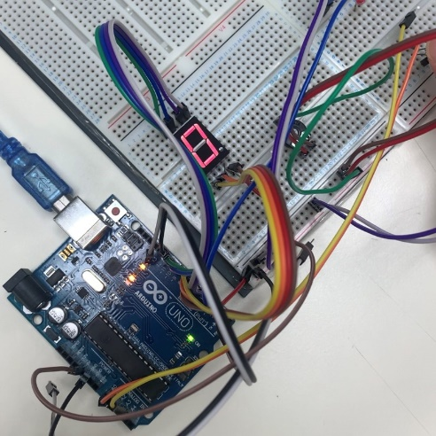**Diagram:**

**Coding:**

void setup()

{

Serial.begin(9600);

attachInterrupt(digitalPinToInterrupt(2),blink,FALLING);

}

void loop()

{

pinMode(A0,INPUT);

pinMode(2,INPUT);

pinMode(4, OUTPUT);

pinMode(12,OUTPUT);

int X;

for (char i=5; i<12; i++)

{

pinMode(i,OUTPUT); //CA

}

int number_09[10][7] ={{0,0,0,0,0,0,1}, //row0

{1,0,0,1,1,1,1}, //row1

{0,0,1,0,0,1,0}, //row2

{0,0,0,0,1,1,0}, //row3

{1,0,0,1,1,0,0}, //row4

{0,1,0,0,1,0,0}, //row5

{0,1,0,0,0,0,0}, //row6

{0,0,0,1,1,1,1}, //row7

{0,0,0,0,0,0,0}, //row8

{0,0,0,0,1,0,0},};//row9 //a,b,c,d,e,f,g

for (char row=0; row<10; row++)

{

for (char pin=5; pin<12; pin++)

{

digitalWrite(pin,number_09[row][pin-5]);

}

X=analogRead(A0);

Serial.println(X);

if(X>400)

{

digitalWrite(12,HIGH);

}

else

{

digitalWrite(12,LOW);

digitalWrite(12,HIGH);

}

delay(1000);

}

}

void blink()

{

digitalWrite(4,HIGH);

delay(200);

digitalWrite(4,LOW);

}

**Result:**

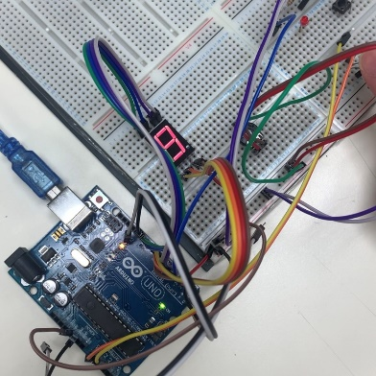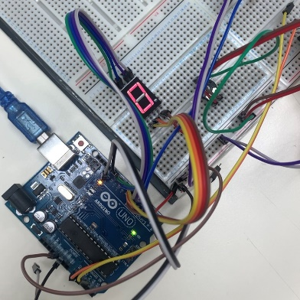

**Figure 7.5.1:** LED ‘0’ until ‘9’ repeatedly

But LDR is in dark , Buzzer is on.

**Conclusion:**

In chapter seven, a timer and external interrupts were introduced. Timer function allows an action to be performed repeatedly through a certain period of time without trigger requirement. However, a prescaler is required to be calculated based on the amount of time the action lasts. Whereas interrupt’s function allows an action to be performed immediately as soon as a certain interruption occurs which considered a top priority action among all.